When Purpose Meets Payoff: How Program, Institution, and Field Shape Postsecondary Value
Authors: Daniella Paradise, Kim Dancy, and Rosario Durán
Contributors: Erin Dunlop Velez and Jocelyn Salguero
Executive Summary 3
Programs of Value 3
Failing Programs 4
Programs in Socially Valuable Fields 4
Measures of Value Beyond Earnings 4
Policy Recommendations 5
Introduction 6
How We Assess Value 9
Programs of Value 12
Overall Program Performance 12
Program Performance by Credential Level 14
Program Performance by Institutional Control 18
Program Performance Within Education, Human Development and Family Studies, and Social Work Fields 20
Failing Programs 22
Measures of Value Beyond Earnings 24
Access to Benefits by Field and Credential Level 24
Access to and Satisfaction with Benefits Among Bachelor’s Degree Holders 27
Policy Recommendations 29
Support and Incentivize Strong Outcomes for All Students 29
Invest in Affordability to Improve Value 30
Improve Data and Promote Transparency in Higher Education 31
Conclusion 34
Appendix: Methodology 35
Earnings Value Methodology 35
Nonearnings Value Methodology 40
Notes 42

Executive Summary
Higher education remains one of the surest paths to economic mobility and financial security, but students still see varying returns on their credentials, depending on the institution they attend, the credential they pursue, and their field of study.
When Purpose Meets Payoff: How Program, Institution, and Field Shape Postsecondary Value evaluates undergraduate programs’ postgraduate earnings outcomes using data from the College Scorecard and compares them to two benchmarks. The first, the earnings premium threshold in the One Big Beautiful Bill Act (OB3), requires postgraduate earnings for all programs that receive federal loans to be higher than the earnings of a typical high school graduate. The second, the Postsecondary Value Commission’s Threshold 0, measures whether students are better off financially for having earned their credential, after accounting for the costs of college.

Programs of Value
The majority of graduates attended programs that perform well against the OB3 earnings threshold, usually regardless of field. But fewer graduates attended programs that pass Threshold 0, indicating that a number of programs produce earnings above a high school graduate’s without fully offsetting the cost of college attendance.
- Nearly all bachelor’s degree recipients, including in highly socially valuable fields like Education and Social Work, attended programs that pass the OB3 threshold, and 90 percent attended programs that pass Threshold 0.
- Associate’s degree programs perform almost as well as bachelor’s degree programs: 96 percent of associate’s degree holders attended programs that pass the OB3 threshold and 86 percent attended programs that pass Threshold 0.
- Public institutions perform especially well: 99 percent of undergraduates attended programs that pass the OB3 threshold and 91 percent attended programs that also meet Threshold 0.
- While 92 percent of graduates from private nonprofit institutions attended programs that meet the OB3 threshold, in many fields substantially fewer graduates attended programs that pass Threshold 0, likely due to higher costs.

Failing Programs
Programs at for-profit institutions and certificates across all institution types account for most failing programs. These trends have important implications for which students are most at risk of earning a credential with little financial value and which programs are most likely to be affected by accountability policy.
- Although certificate programs produce only 24 percent of all graduates, they account for 91 percent of graduates from programs that fail the OB3 threshold.
- For-profit programs account for 35 percent of all graduates, but 85 percent of graduates from programs that fail the OB3 threshold, likely because, in our sample, the majority of for-profit programs are certificates.

Programs in Socially Valuable Fields
Undergraduate programs in Education, Human Development and Family Studies (which includes early childhood education programs), and Social Work pass the OB3 threshold at high rates but clear Threshold 0 less consistently, following many of the same patterns as other programs.
- Most graduates in these fields attended programs that pass the OB3 earnings premium threshold, though certificate programs are a notable exception.
- Approximately nine out of ten graduates in Social Work attended programs that pass Threshold 0. But some specific field categories within Education, particularly those containing early childhood education programs, fall short of Threshold 0 more often, reflecting higher costs relative to earnings.

Measures of Value Beyond Earnings
Earnings alone do not capture the full scope of postsecondary value. We use data from the Baccalaureate and Beyond Longitudinal Study and the Beginning Postsecondary Students Longitudinal Study to investigate graduates’ access to and satisfaction with employer-provided benefits like health insurance, paid time off, and retirement plans.
While benefits are fairly accessible in socially valuable fields, they do not appear available enough to fully offset the lower earnings associated with many of these professions. And while graduates in these fields often report satisfaction with their job security, dissatisfaction with compensation remains persistent and heightened, making it clear that nonearnings factors provide an important but insufficient counterweight to lower pay.
- The likelihood of Education graduates having access to benefits is typically greater for more advanced credentials. In contrast, Public Administration and Social Services (which includes Social Work programs) stands out as one of the few fields where access to benefits does not increase with credential level.
- Graduates in Education as well as Public Administration and Social Services report satisfaction with their job security at or above the average rate. But graduates in both fields fall below the average rate of satisfaction with compensation, reinforcing the importance of earnings outcomes.

Policy Recommendations
Though financial returns are just one dimension of postsecondary value, programs should not consistently leave students worse off than if they had never attended, even if they are pursuing public service careers. Federal, state, and institutional leaders each have a role to play in ensuring programs deliver a minimum economic return by addressing three areas:
- Support and incentivize strong outcomes for all students.
  - Federal policymakers should enforce minimum standards for post-college earnings across all programs of study.
  - Institutions and employers should improve the education-to-career pipeline.
  - States and employers should provide additional support to workers in highly socially valuable fields by increasing wages, revising credentialing and licensing requirements, and providing targeted financial support.
- Invest in affordability to improve value.
  - Congress should protect and increase funding for Federal Pell Grants.
  - States should expand investments in higher education.
  - Institutions should invest in need-based financial aid.
- Improve data and promote transparency in higher education.
  - Congress should pass the College Transparency Act and create a federal student-level data network to address gaps in available data about postsecondary student outcomes.
  - The U.S. Department of Education (ED) should ensure the timely implementation of the Student Tuition and Transparency System (STATS), publish the Financial Value Transparency (FVT) data already reported by institutions, and integrate STATS program-level cost and outcomes data with the College Scorecard.
  - ED should reinstate and expand longitudinal, nationally representative studies that provide information about the nonearnings benefits of higher education.
  - Federal and state policymakers should invest in modernizing and maintaining state data systems to promote evidence-driven policymaking.

Introduction
Earning a college degree remains one of the most powerful ways to provide lasting benefits to students, communities, and the economy. But students still see returns that vary depending on the institution they attend, the level of credential they pursue, and the field of study they choose.
Often, high-paying fields are those that prepare students with skills and expertise that are in high demand among employers. In other fields, like social work and education, typical compensation is far less than the value these professions produce for society. As a result, students in fields with high social value face a difficult reality: Their programs prepare them for essential work, but their post-college earnings do not always reflect their full value.
This gap matters because all students deserve a high-quality education that leaves them better off financially than they were before. The fact that students entering fields with high social value often face low wages—particularly when women and Black students are disproportionately likely to enter high social value, low-wage fields—is highly problematic.
Additionally, the adoption of earnings-based accountability standards in the One Big Beautiful Bill Act (OB3) has raised the stakes by tying each program’s eligibility for federal loans to a minimum standard for the post-college earnings of its graduates. This law requires that programs at all types of institutions leave students, on average, better off than if they had never attended. As a result, some have raised questions about how fields with relatively low earnings but high social value fare against the OB3 earnings premium threshold.
These concerns about affordability in higher education call for a closer look at how students across different fields of study recoup their investment. The Postsecondary Value Commission’s Threshold 0 measures whether students are better off financially after attending college, even after accounting for their investments in higher education. Comparing program outcomes to Threshold 0 in addition to the new OB3 benchmark indicates which fields are most likely to pay off for students. Further, understanding credentials beyond their earning potential, including benefits like work-life balance and job security, offers a more complete view of their true value.
To examine program value by field of study, this report leverages program-level data to compare undergraduate programs’ postgraduate earnings with the OB3 earnings premium threshold and Threshold 0. We also use student-level data to investigate other measures of value beyond earnings, including graduates’ access to and satisfaction with employer-provided benefits.
We focus on undergraduate programs in Education, Human Development and Family Studies (which includes early childhood education programs), and Social Work as widely recognized examples of high social value, low-wage fields that often require a college credential. These are by no means the only socially valuable fields, but they are examples to illustrate how social value and economic returns intersect.
We find that the vast majority of graduates attended programs that meet the OB3 earnings premium threshold, though certificate programs and programs at for-profit institutions are far less likely to do so. Notably fewer graduates attended programs that pass Threshold 0, particularly in socially valuable fields, indicating that numerous programs produce earnings above a high school graduate’s but do not fully offset the cost of college attendance.
Furthermore, while nonearnings factors like access to paid time off and health insurance tend to be accessible in socially valuable fields, graduates’ dissatisfaction with compensation is high, indicating that these job benefits provide an important but insufficient counterweight to the lower earnings associated with many socially valuable professions.
Our findings show that a wide range of programs can and often do demonstrate positive value for graduates. But while many students do not have to choose between public service careers and their own financial security, some programs do fall short in this regard.
This report first describes how programs and graduates perform against the earnings thresholds by field of study, credential level, and institutional control (whether a school is public, private nonprofit, or for-profit). We then examine outcomes of more specific field categories within Education, Human Development and Family Studies, and Social Work. We explore the makeup of failing programs and review access to and satisfaction with employer-provided benefits for graduates in different fields and credential levels. We conclude by giving policy recommendations focused on ensuring a minimum economic return across programs, investing in affordability to increase value for students, and improving data and transparency in higher education.
In conducting this research, we evaluated earnings data in more detail and to a greater extent than we could include in this report. To explore the detailed data, visit our data dashboard at www.ihep.org/PurposeMeetsPayoff.

Side Box 1. The Postsecondary Value Commission

The Postsecondary Value Commission, managed by the Institute for Higher Education Policy, brought together college leaders, policymakers, researchers, advocates, and students to propose a definition of postsecondary value, develop a way to measure that value, and urge action to improve value and make postsecondary education more equitable.

Postsecondary value includes both economic and non-economic benefits to students, communities, and society. The Commission’s Postsecondary Value Framework outlines a robust set of metrics that stakeholders can use to assess value, including a series of economic value thresholds that measure post-college earnings and wealth outcomes of students.

In this report, we use the first of these thresholds, Threshold 0, to evaluate the economic value of various programs of study. To learn more, visit www.postsecondaryvalue.org.

How We Assess Value
We evaluate undergraduate programs’ postgraduate earnings relative to two earnings benchmarks: the OB3 earnings premium threshold and Threshold 0.
OB3 Earnings Premium Threshold = median earnings of high school graduates

Threshold 0 = median earnings of high school graduates plus enough to recoup cumulative net price of college credential within ten years

To calculate both thresholds, we use the 2024 American Community Survey 5-Year sample to measure the median earnings of high school graduates, by state and nationally. For Threshold 0, we also use Integrated Postsecondary Education Data System (IPEDS) data to calculate the net price students pay for college. Using program-level College Scorecard data, we then compare these thresholds to each program’s median graduate earnings four years after completion. A program passes a threshold when its median graduate earnings meet or exceed the threshold value.
Our analysis includes all Title IV undergraduate programs with valid earnings data in the most recent College Scorecard—a total of 42,392 programs. An additional 106,599 undergraduate programs are excluded from this analysis due to missing earnings data. All results apply only to programs with available program-level earnings data.
Calculating Threshold 0 also requires information on costs for each institution, so only programs with earnings data and academic-year cost data from IPEDS are included in Threshold 0 analyses. Some programs included in the OB3 premium threshold results are not included in the Threshold 0 results, which reduces the total number of programs analyzed against Threshold 0 to 37,397. (For more information on missing cost and earnings data, see Side Box 3. Missing Data Between Thresholds.)
The OB3 threshold sets a low earnings bar because it compares graduates’ earnings only to those of a typical high school graduate. Threshold 0 also accounts for what students pay for college. A program that looks strong under OB3 may still leave students with limited financial gain once postsecondary costs are included. This means that for each program, the earnings needed to pass Threshold 0 are always higher than the earnings needed to pass the OB3 earnings threshold. However, because of missing data, different numbers of programs in the denominator in some cases cause a larger percentage of programs in our analysis to pass Threshold 0 than the OB3 threshold.

In most cases, we report results as the percentage of graduates in the earnings cohort who attended programs with earnings data that pass each threshold, as opposed to the percentage of programs that pass. This format better illustrates the number of students affected by program performance. The program earnings measure includes all graduates of programs with non-missing earnings data who received federal financial aid, are employed, and are not enrolled in a postsecondary program four years after graduation.
Throughout this report, we present field of study results by combining two-digit Classification of Instructional Programs (CIP) codes created by the U.S. Department of Education into broad, field of study categories, with a few exceptions. To highlight socially valuable fields, we analyze Human Development and Family Studies (a CIP code which contains many early childhood programs, along with other highly socially valuable fields) and Social Work separately from other programs in the same two-digit CIP codes. The analysis also includes results for Education programs as a whole and, in some sections, for more specific categories within Education.
To analyze outcomes beyond earnings, we use nationally representative survey data from the 2016/20 Baccalaureate and Beyond Longitudinal Study (B&B) to examine early-career employment characteristics for bachelor’s degree recipients approximately four years after graduation, including access to health insurance, paid time off, and retirement plans and satisfaction with work-life balance, job security, benefits, and compensation. We also use data from the 2012/17 Beginning Postsecondary Students Longitudinal Study (BPS) to extend the analysis to certificate and associate’s degree recipients and examine the share of those individuals eligible for health insurance, paid time off, and retirement plans by highest credential attained.
Side Box 2. Critical Studies Remain Under Threat
This report and similar research depend on federal longitudinal data collections. Large, nationally representative studies like B&B and BPS track students’ experiences over time, helping researchers and policymakers to understand how significant events shape student outcomes across different populations. This report is only possible because of these data. Yet, the federal contract for future BPS data collections has been cancelled, putting this essential source of insights at risk. Sustained investment in longitudinal studies like BPS is essential to understanding student experiences and improving outcomes.

Programs of Value

Overall Program Performance
The vast majority of undergraduate programs with available data meet both earnings thresholds (see Table 1). The median earnings of 93 percent of programs exceed the OB3 earnings premium threshold, and these programs account for 88 percent of college graduates. Most programs with available data also pass Threshold 0 (82 percent of programs producing 87 percent of graduates), which means their median earnings are also enough to recover the cost of attending college.
Performance depends considerably on a program’s credential level. Nearly all bachelor’s degree graduates in our analysis (over 99 percent) attended programs that pass the OB3 earnings threshold, and the vast majority (90 percent) also attended programs that pass Threshold 0. Associate’s degree programs perform similarly to bachelor’s degree programs: 96 percent of associate’s degree recipients attended programs that pass the OB3 threshold and 86 percent attended programs that pass Threshold 0. In contrast, only 55 percent of certificate holders attended programs that pass the OB3 threshold, calling into question the value of many programs at this level.
Performance also varies by institutional control. Nearly all graduates (99 percent) from public institutions attended programs that pass the OB3 threshold and 91 percent attended programs with earnings that also meet Threshold 0. These students are much more likely to have attended passing programs than those who attended for-profit institutions: only 71 percent of graduates from for-profit institutions attended programs that pass the OB3 earnings threshold. This lower rate likely reflects credential-level differences, as most for-profit programs in our sample award certificates. And while 92 percent of graduates from private nonprofit institutions attended programs that meet the OB3 threshold, substantially fewer graduates (75 percent) attended programs that pass Threshold 0, likely due to relatively higher costs of attendance at this type of institution.

Table 1. Percentage of Passing Programs and of Graduates in Passing Programs, by Institutional Control and Credential Level
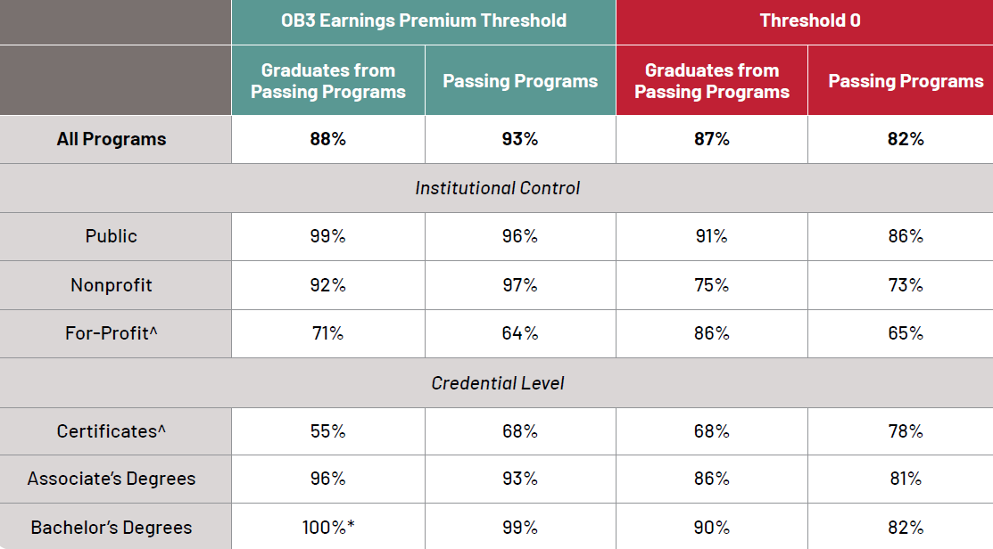 ^= Interpret with caution because of large differences in denominators due to missing data required to calculate Threshold 0, which can result in the percentage passing Threshold 0 to be greater than the percentage passing OB3. See the section Missing Data Between Thresholds for more details.
*Rounds to 100%.

Note: Graduates include all completers who receive federal financial aid and who are working but not enrolled four years after leaving school. All calculations exclude programs and graduates of programs without earnings data. Threshold 0 calculations exclude programs without academic-year cost information. Denominators differ between thresholds.

Source: IHEP analysis of data from the College Scorecard, IPEDS, and the American Community Survey.

Side Box 3. Missing Data Between Thresholds
For both thresholds, our analysis requires program earnings data; however, Threshold 0 also requires academic-year cost information at the institution level to calculate whether program graduates earn enough to recoup the cost of their credential. Consequentially, programs without cost information are included in results for the OB3 earnings premium threshold but must be excluded from results for Threshold 0. Because of missing cost data, different numbers of programs in the denominator in some cases cause a larger percentage of programs in our analysis to pass Threshold 0 than the OB3 threshold, despite fewer programs passing Threshold 0 than the OB3 threshold.
For example, 78 percent of certificate programs pass Threshold 0 and only 68 percent pass the OB3 earnings premium threshold (see Table 1). However, the Threshold 0 calculation includes 3,531 fewer certificate programs than the OB3 calculation. As a result, only 2,805 certificate programs pass Threshold 0, compared to 4,805 programs that pass the OB3 earnings premium:
OB3 Earnings Premium Threshold |  | Threshold 0
4,805 programs pass  7,113 programs  with sufficient data | = 68 percent pass rate | 2,805 programs pass  3,582 programs  with sufficient data | = 78 percent pass rate
Note that programs lacking academic year cost information are not evenly distributed. For example, at least 50 percent of for-profit programs and certificate programs with earnings information are missing cost information, compared to only 3 percent of public and bachelor’s degree programs with earnings information. Missing programs are also unevenly distributed across fields of study. For details about missing data across characteristics, visit the accompanying data dashboard.
Missing cost or earnings data make it more difficult to understand which programs and institutions perform well against these value thresholds. Missing cost information also complicates comparisons between thresholds and limits evaluation of program affordability. More data accessibility is vital to overcoming these challenges.

Program Performance by Credential Level
Graduates’ typical post-college earnings vary enormously across fields of study, making it important to evaluate threshold pass rates by specific field of study.
In many fields across credential levels, most graduates attended programs that pass the OB3 earnings premium threshold and Threshold 0 (see Figure 1). Bachelor’s degree programs perform especially well against both thresholds. Nearly all bachelor’s degree holders attended programs that pass the OB3 earnings threshold, including Education and Social Work graduates. This indicates that nearly all bachelor’s degree programs provide a minimum economic return to students regardless of field of study.
However, the share of graduates from programs that pass Threshold 0 is consistently lower than the share for the OB3 threshold, and in some cases the share is dramatically lower. For example, almost all bachelor’s degree holders in Human Development and Family Studies (97 percent) attended programs that pass the OB3 threshold, but only 58 percent of graduates in this field attended programs that also meet Threshold 0. Among associate’s degree recipients in Education, 78 percent attended programs that pass the OB3 threshold, while only 36 percent attended programs that also meet Threshold 0. And in Social Work, 93 percent of associate’s degree holders attended programs that pass the OB3 threshold, but that figure drops to 57 percent against Threshold 0. Most fields see this gap in OB3 and Threshold 0 pass rates. This trend shows that while graduates in these programs are consistently earning more than a high school graduate, they are not always earning enough to recoup the cost of their education.
Certificate and associate’s degree programs show the widest variation in outcomes. In some fields, such as Architecture and Engineering, nearly all graduates in both credential types attended programs that pass both thresholds. In other fields, only a small number of graduates see a return. For instance, only about half of certificate holders in Education attended programs that pass the OB3 threshold, though this matches the average pass rate for certificates overall (see Table 1 above). And graduates within Human Development and Family Studies have the lowest passing rates of any field, with only 27 percent of certificate recipients and 61 percent of associate’s degree recipients attending programs that exceed the OB3 earnings premium.
These low pass rates for some certificates and associate’s degrees reflect the fact that many graduates of these programs experience truly low earnings. Median earnings for high school graduates in each state range from just $31,000 to $42,000, and only programs with typical graduate earnings less than that amount fail the OB3 benchmark. To exceed Threshold 0, the median program in our sample only needs to surpass $46,000 in earnings. This means the thresholds that programs need to meet are relatively low, and graduate earnings are even lower for programs that fail.
Low pass rates have different implications, depending on the field and credential level. For example, many social work and education positions require a bachelor’s degree or higher, while many early childhood educators need only an associate’s degree or lower. So while outcomes for Social Work certificates may not have a large bearing on the earnings of most social work professionals, low earnings for Human Development and Family Studies certificates have more harmful implications for early childhood educators.

Figure 1. Percentage of Graduates in Passing Programs, by Credential Level and Field of Study

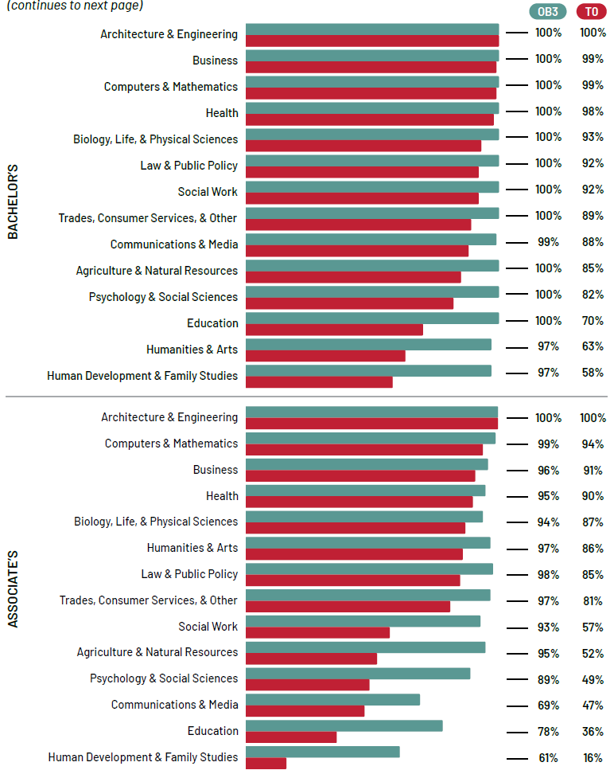

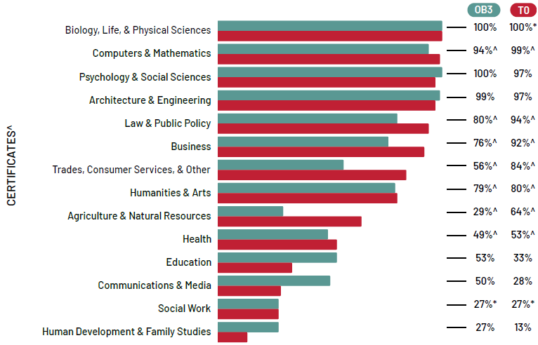

* = Interpret with caution because of low numbers of underlying programs in the denominator.
^= Interpret with caution because of large differences in denominators due to missing data required to calculate Threshold 0; this can result in the percentage passing Threshold 0 to be greater than the percentage passing OB3. See the section Missing Data Between Thresholds for more details.

Note: Graduates include all completers who receive federal financial aid who are working but not enrolled four years after leaving school. All calculations exclude graduates of programs without earnings data. Threshold 0 calculations exclude programs without academic-year cost information. Denominators differ between thresholds. The Education category includes Library Science programs, though there are fewer than ten Library Science programs with earnings data in the results.

Source: IHEP analysis of data from the College Scorecard, IPEDS, and the American Community Survey.

Program Performance by Institutional Control
Undergraduate program value also varies widely depending on whether the program is at a public, private nonprofit, or for-profit institution. In nearly all fields, most graduates from public institutions attended programs that pass both the OB3 earnings premium threshold and Threshold 0 (see Figure 2). Education programs and Human Development and Family Studies programs are exceptions. While they perform almost universally well against the OB3 threshold, only 74 percent and 52 percent of graduates, respectively, attended programs that pass Threshold 0.
Private nonprofit programs consistently perform well against the OB3 threshold, with many fields showing close to 100 percent of graduates attending passing programs. This includes Education and Social Work, where most graduates attended programs that pass the OB3 threshold, not just at nonprofit institutions, but at all institution types. However, in many fields, the percentage of graduates from nonprofit programs that pass Threshold 0 is substantially smaller than the percentage for the OB3 earnings premium, probably due to the high cost of these institutions relative to those in the public sector. Only 75 percent of Social Work graduates, 50 percent of Education graduates, and 35 percent of Human Development and Family Studies graduates attended programs that meet Threshold 0.
Programs at for-profit institutions perform inconsistently against the OB3 earnings premium threshold. For some fields, including Education, most graduates attended programs that exceed this threshold. In other cases, only about half to three-quarters of graduates attended for-profit programs that pass the OB3 threshold, reflecting weaker earnings outcomes. For Threshold 0, in some fields, a large share of graduates attended programs that pass, but in other cases pass rates are quite low. For example, less than 40 percent of Education graduates or Human Development and Family Studies graduates from for-profit institutions attended programs that pass Threshold 0. Low Threshold 0 pass rates in these fields across all institution types highlight significant room for improvement in college affordability.

Figure 2. Percentage of Graduates in Passing Programs, by Institutional Control and Field of Study

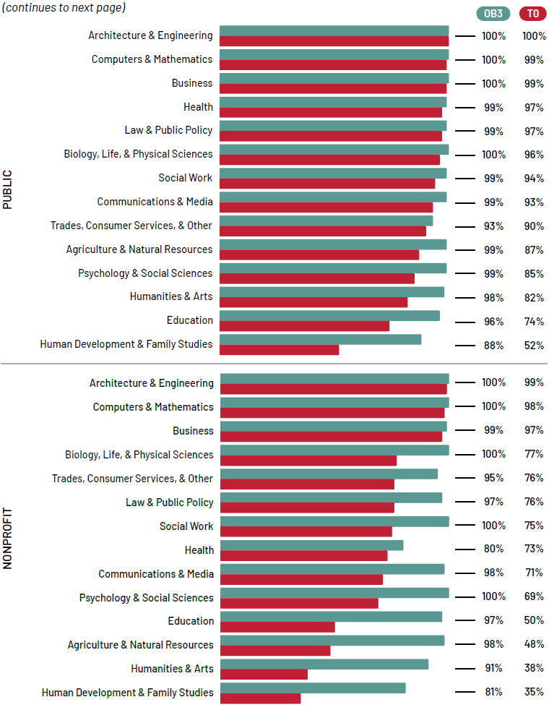
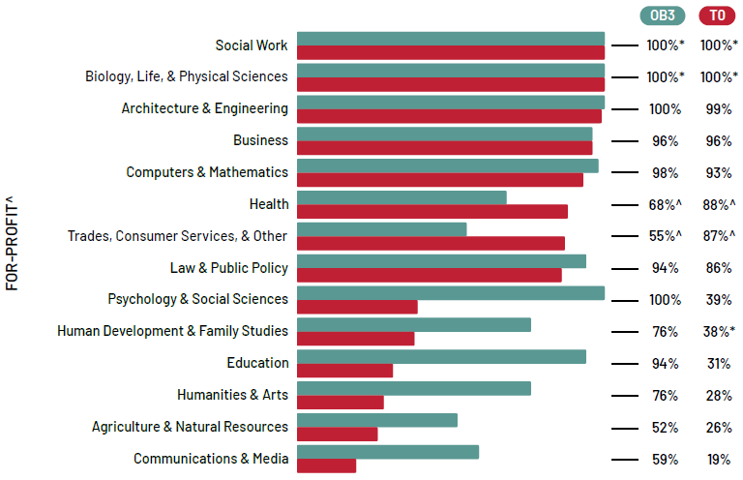

* = Interpret with caution because of low numbers of underlying programs in the denominator.
^= Interpret with caution because of large differences in denominators due to missing data required to calculate Threshold 0; this can result in the percentage passing Threshold 0 to be greater than the percentage passing OB3. See the section Missing Data Between Thresholds for more details.

Note: Graduates include all completers who receive federal financial aid who are working but not enrolled four years after leaving school. All calculations exclude graduates of programs without earnings data. Threshold 0 calculations exclude programs without academic-year cost information. Denominators differ between thresholds. The Education category includes Library Science programs, though there are fewer than ten Library Science programs with earnings data in the results.

Source: IHEP analysis of data from the College Scorecard, IPEDS, and the American Community Survey.

Program Performance Within Education, Human Development and Family Studies, and Social Work Fields
High social value fields are not typically associated with high earnings, despite providing substantial benefits to society. These fields often emphasize service to others and bring significant value to communities, in addition to potential individual, nonearnings benefits such as personal satisfaction.
Defining these fields is imprecise and often debated. Social Work, Human Development and Family Studies, and Education include some of the most commonly cited fields that often require a college credential because they prepare students for careers focused on teaching, caregiving, and public service. The broad field of Education includes programs in a variety of more specific field categories. In this section we present results broken down by those fields within Education, along with results for Human Development and Family Studies and Social Work (see Figure 3).
Despite generally lower wages, many Education and Social Work programs still provide economic value for graduates and perform well against the earnings thresholds. Most graduates in each of the more specific Education fields attended undergraduate programs that pass the OB3 earnings premium threshold, though this is typically not the case for certificates (as shown in Figure 1). Approximately nine out of ten graduates in Social Work and the category “Teacher Education and Professional Development, Specific Subject Areas” within Education also attended programs that pass Threshold 0. These outcomes suggest widespread availability of valuable credentials.
Other fields show weaker passing rates against Threshold 0, indicating high costs compared to earnings. In Human Development and Family Studies and the Education field “Teacher Education and Professional Development, Specific Levels and Methods,” less than 60 percent of graduates attended programs that meet Threshold 0. Many programs in these field categories are in early childhood education. These findings are consistent with other research showing that early childhood educators often receive low wages, especially for the level of credential sometimes required by those occupations.

Figure 3. Percentage of Graduates in Passing Programs, by Social Work, Human Development and Family Studies, and Specific Education Fields
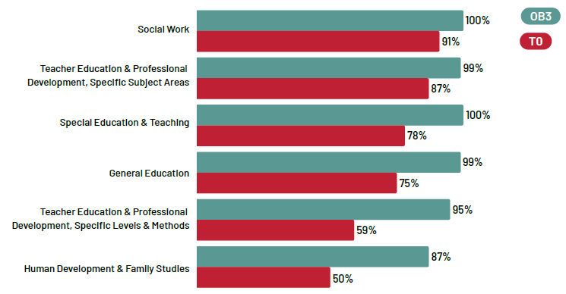
Note: Graduates include all completers who receive federal financial aid who are working but not enrolled four years after leaving school. All calculations exclude graduates of programs without earnings data. Threshold 0 calculations exclude programs without academic-year cost information. Denominators differ between thresholds. Human Development and Family Studies is a four-digit CIP code within Family and Consumer Sciences/Human Sciences. Social Work is a four-digit CIP code within Public Administration and Social Service Professions. All other listed fields are four-digit CIP codes within Education. The following Education four-digit CIP codes that have fewer than 20 programs or are described as an “Other” CIP code are excluded: Supervision; Educational/Instructional Media Design; Educational Assessment, Evaluation, and Research; International and Comparative Education; Social and Philosophical Foundations of Education; Student Counseling and Personnel Services; Teaching English or French as a Second or Foreign Language; Teaching Assistants/Aides; Other, Education.

Source: IHEP analysis of data from the College Scorecard, IPEDS, and the American Community Survey.

Failing Programs
Thus far, we have shown how students fare within each kind of credential and institutional control. Certificate programs and programs at for-profit institutions have particularly low passing rates against both earnings thresholds. Past research also indicates that certificate and for-profit programs are overrepresented among programs that fail the OB3 threshold relative to their share of all programs and students. This trend has implications not just for which students are most at risk of earning a credential with little financial value, but also for which credentials and institutions are most likely to be affected by accountability policy measures.
Our analysis confirms that certificate programs are dramatically overrepresented among graduates of failing programs, especially looking at the OB3 earnings premium threshold (see Figure 4). While certificate programs produce only 24 percent of all graduates, they account for 91 percent of graduates who attended failing programs. In comparison, it’s unlikely for a student of a failing program to be at the bachelor’s level. Bachelor’s degree programs make up over half of graduates overall, but just 2 percent of graduates from programs that fail the OB3 threshold.
Similarly, programs at for-profit institutions account for an oversized share of the graduates whose programs fail the OB3 threshold. Only 35 percent of all graduates attended for-profit programs, but for-profit programs account for 85 percent of graduates from failing programs (this is likely because a majority of for-profit programs in our sample are certificates). Conversely, public programs account for 50 percent of all graduates and only 6 percent of graduates from programs that fail the OB3 threshold. And while private nonprofit programs make up less than their proportional share of graduates from programs that fail the OB3 threshold, they are overrepresented among graduates from programs that fail Threshold 0, likely reflecting higher costs at nonprofit institutions.

Figure 4. Proportion of Graduates in All Programs Versus Failing Programs, by Credential Level and Institutional Control
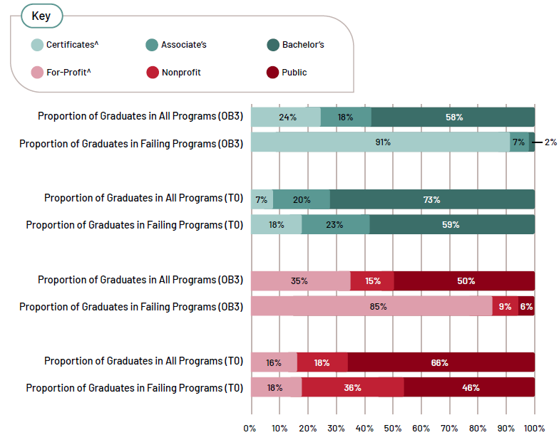
^= Interpret with caution because of large differences in denominators due to missing data required to calculate Threshold 0. See the section Missing Data Between Thresholds for more details.

Note: Graduates include all completers who receive federal financial aid who are working but not enrolled four years after leaving school. All calculations exclude graduates of programs without earnings data. Additionally, Threshold 0 calculations exclude programs without academic-year cost information. Denominators differ between thresholds.

Source: IHEP analysis of data from the College Scorecard, IPEDS, and the American Community Survey.

Measures of Value Beyond Earnings
Earnings alone do not capture the full scope of postsecondary value or graduate outcomes. A broader definition of success is particularly relevant for fields with lower earnings, since factors like work-life balance, job security, and access to employer-provided benefits such as health insurance, paid time off, and retirement plans add to total compensation.
While data on many nonearnings aspects of value are not often available, nationally representative data from the Baccalaureate and Beyond Longitudinal Study (B&B) and the Beginning Postsecondary Students Longitudinal Study (BPS) allow us to examine access to employment benefits and measures of career satisfaction among graduates.

Access to Benefits by Field and Credential Level
Overall, access to health insurance coverage, paid time off, and retirement savings accounts increases with educational attainment (see Table 2). Bachelor's degree recipients generally report the highest rates of access to all types of benefits, followed by associate's degree holders, with certificate holders reporting the lowest rates.
For Education graduates, the level of access to benefits, relative to other fields, varies across credential levels. At the associate’s degree level, Education graduates have some of the lowest access to health insurance (60 percent), paid time off (72 percent), and retirement benefits (55 percent) of any field. But at the bachelor’s degree level, more than three in four Education graduates report access to health insurance, paid time off, and retirement benefits, indicating widespread, above-average benefit coverage. Most teaching occupations require at least a bachelor's degree, which means that most Education graduates who become teachers likely have access to strong benefits.
Public Administration and Social Services, a field which includes Social Work in this dataset, stands out as one of the few fields where access to benefits does not increase with credential level. Public Administration and Social Services graduates at the certificate level report the highest access to paid time off of any field (96 percent), while bachelor’s degree holders report the lowest access (roughly 64 percent). And while associate’s degree recipients in this field report average rates of access to benefits, bachelor’s degree recipients report below-average access to all benefits, relative to other fields.
These findings show that socially valuable fields can provide meaningful access to employer-sponsored benefits for many graduates, but they do so inconsistently. And while benefits represent an important part of overall compensation, they do not appear available enough to fully offset the lower earnings associated with many socially valuable professions. This more complete understanding of program value therefore affirms the need for minimum earnings standards across fields.

Table 2. Access to Nonearnings Benefits, by Credential Level and Field of Study
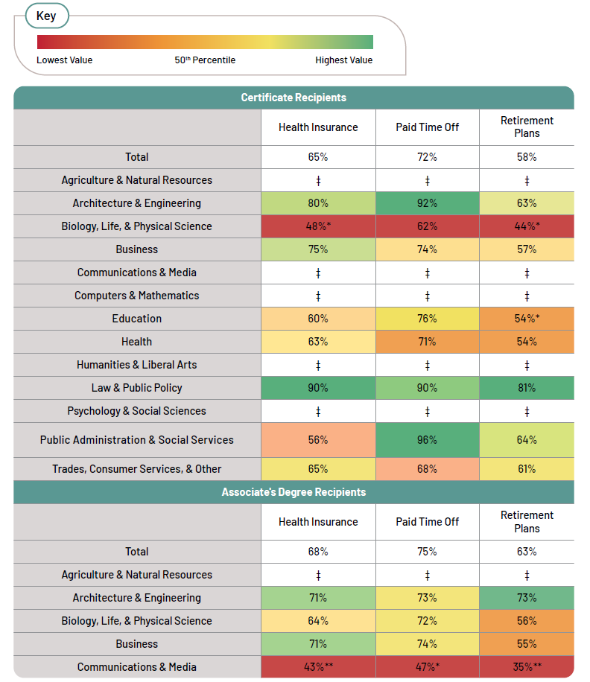
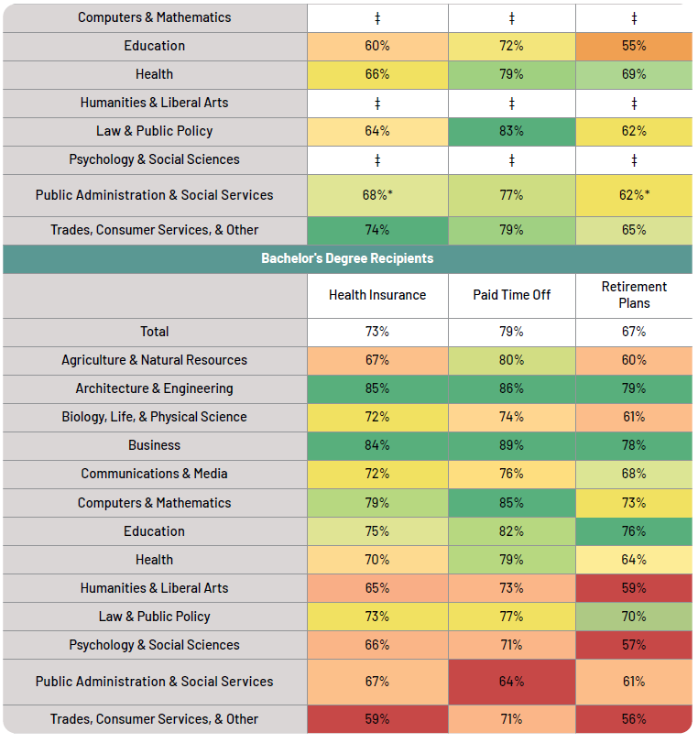
‡ = Estimate does not meet reporting standards.
* = Use caution when interpreting this estimate because its standard error is between 30% and 50% of the estimate, indicating some instability.
** = Use caution when interpreting this estimate because its standard error is more than 50% of the estimate, making it highly unstable.

Note: The names of the variables used in this analysis are: JBEN17B, JBEN17D, JBEN17C, MAJORS, and ATLTY6Y. The weight variable used in this analysis is WTA000. The code to retrieve results is kxtahj.

Source: IHEP analysis of the 2012/17 Beginning Postsecondary Students Longitudinal Study.

Access to and Satisfaction with Benefits Among Bachelor’s Degree Holders
Data from B&B allow us to further examine the extent to which bachelor’s degree holders, particularly those in socially valuable fields, access employer-sponsored benefits and report satisfaction with different elements of their jobs.
On average, more than 75 percent of bachelor’s degree recipients report access to health insurance, paid time off, and retirement plans (see Table 3). Education as well as Public Administration and Social Services graduates have above-average access to benefits, with more than eight in ten graduates in these fields reporting access to all three types of benefits.
In terms of satisfaction with aspects of employment, bachelor's degree recipients are most satisfied with their job security. Graduates in Education have some of the highest rates of job security satisfaction, suggesting strong demand for workers in this field. Job security satisfaction among Public Administration and Social Services graduates matches the average, at 71 percent. Satisfaction with work-life balance is close to average in both Education and Public Administration and Social Services, at 65 and 69 percent respectively, compared to 68 percent across all bachelor's degree holders.
Graduates feel the least satisfaction with compensation. Fewer than two-thirds of all bachelor’s degree recipients say they are satisfied with their compensation. Education graduates and Public Administration and Social Services graduates fall even lower, with just over half reporting they are satisfied with their compensation. This measure indicates that financial satisfaction remains a common concern even outside specific fields, and it reinforces the importance of earnings outcome measures, such as those described earlier in this report.
In all, consistent access to benefits and high satisfaction with job security at the bachelor’s level are notable strengths of Education and Public Administration and Social Services. Yet financial dissatisfaction remains persistent and heightened in these fields, making it clear that nonearnings factors provide an important but insufficient counterweight to lower pay.

Table 3. Access to and Satisfaction with Benefits Among Bachelor’s Degree Recipients, by Field of Study
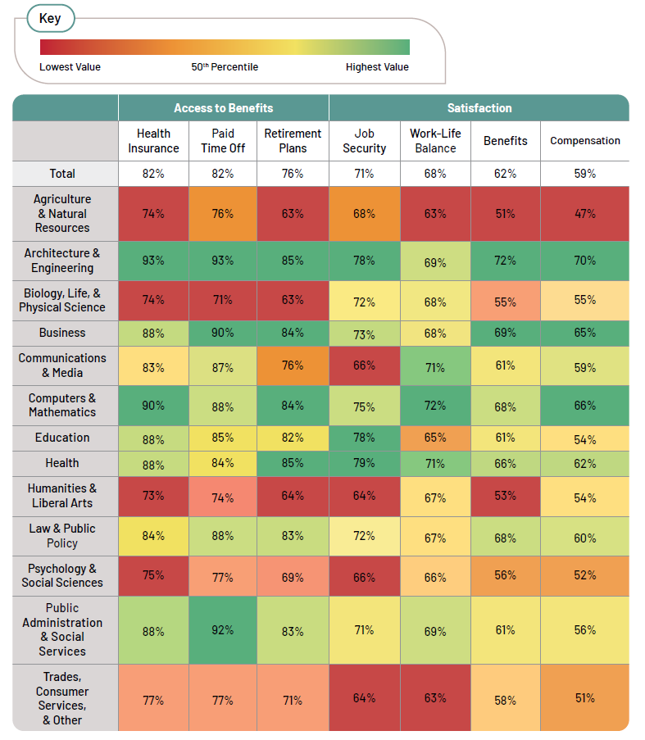
Note: The names of the variables used in this analysis are: B2HINSRCNT, B2PDLVRCNT, B2RETRCNT, B2SECRCNT, B2BALRCNT, B2BENRCNT, B2PAYRCNT, and MAJORS. The weight variable used in this analysis is WTC000. The code to retrieve results is vhffjg.
Source: IHEP analysis of the 2016/20 Baccalaureate and Beyond Longitudinal Study.

Policy Recommendations
While higher education provides both economic and non-economic benefits to individuals and society, pursuing a college degree or credential should lead to increased earnings and greater social mobility. Federal, state, and institutional leaders each have a role to play in ensuring that programs deliver at least a minimum financial return for all students, while employers should ensure that workers in socially valuable fields receive sufficient wages to meet their basic needs. We recommend ten policies and practices, listed below, to support and incentivize strong outcomes for all students, invest in affordability to increase value, and improve data and transparency throughout higher education.

Support and Incentivize Strong Outcomes for All Students
Policymakers, institutional leaders, and employers should work together to ensure that students receive strong labor market outcomes post-college. This includes holding programs accountable for minimum economic returns, strengthening pathways from education to career, and supporting socially valuable careers.
- Federal policymakers should enforce minimum standards on post-college earnings across all programs of study.
Though financial returns are just one dimension of postsecondary value, programs should not consistently leave students worse off than if they had never attended. The U.S. Department of Education’s (ED) final accountability and transparency rule holds all programs accountable for meeting a minimum earnings test. Applying and enforcing this standard across all programs, regardless of credential level, incentivizes institutions to improve outcomes for their students.
- Institutions and employers should improve the education-to-career pipeline.
To ensure strong student outcomes, institutions should strengthen career service offices and partner with local employers to tailor curricula towards employer needs and to strengthen work-based learning opportunities. Opportunities like internships, practicums, and undergraduate research experience can provide early career exposure, increased likelihood of securing a job after college, and higher earnings.
- States and employers should provide additional support to workers in highly socially valuable fields.
States and employers should increase wages and benefits for professions such as educators and social workers by establishing or raising minimum required salaries and strengthening compensation policies. States and employers should consider revising credentialing and licensing requirements based on workforce needs to reduce entry barriers and costs. They can also provide targeted financial support to individuals in these fields, such as tuition assistance, child care subsidies, and paid parental leave.

Invest in Affordability to Improve Value
The federal government, states, and institutional leaders should prioritize postsecondary affordability, as students’ ability to recoup their investment is a vital component of a program’s value, as measured through Threshold 0. Improving the affordability of credentials, particularly in socially valuable fields of study, can help ensure that these programs provide graduates with a strong return on investment.
- Congress should protect and increase funding for Federal Pell Grants.
At its peak in 1975–76, the maximum Pell Grant amount covered more than three-quarters of the cost of attending a public four-year institution. In 2026, the maximum Pell amount only covers 24 percent of those costs. Congress should increase the maximum Pell Grant to restore its purchasing power and provide sufficient Pell funding to support college access and affordability for students from low-income backgrounds. If Congress does not fill a projected $16.9 billion Pell Grant shortfall for fiscal years 2026 and 2027, students could face reduced award amounts or reduced eligibility, which will threaten their ability to afford college.
Transitioning Pell Grants to fully mandatory funding would ensure long-term stability for this critical financial aid program. Though Pell Grants operate as an entitlement for students, where all eligible students receive a Pell award, the program is not funded like an entitlement. Instead, it relies on both mandatory and discretionary funds, which makes the Pell Grant program vulnerable to shortfalls when costs exceed available funding. In the past, those shortfalls have led to Pell Grant cuts that harm students.
- States should expand investments in higher education to improve affordability.
States should invest in need-based financial aid and directly in public institutions to allow those colleges to keep tuition costs low, which can help lower educational costs for students from low-income backgrounds and decrease reliance on student loans.
States should explore targeted investments that make high-need fields more affordable, align funding with workforce priorities, and prioritize fields that deliver significant social value. For example, in 2021, Virginia implemented tuition-free community college to qualified Virginians interested in high-demand careers in trades, technology, and allied health fields. Similarly, New York recently launched free community college programs for students in fields like artificial intelligence, engineering, health care, and education. States should prioritize improving affordability in high social value fields like social work and education to ensure that students’ investments in their education—and in their communities—pay off financially.
- Institutions should invest in need-based financial aid.
To support affordability, institutions should increase financial aid to students, particularly low-income students with demonstrated financial need. Institutions should also fund short-term emergency aid to help students cover unexpected costs and prevent students from dropping out.
Institutions can also improve the affordability of their credentials by helping students complete their programs on time. Reducing time to completion can reduce the number of semesters students are paying for tuition and related living expenses. Institutions can support timely completion by providing clear program pathways, implementing proactive advising, and carefully reviewing program requirements to remove unnecessary barriers and excess credit requirements.

Improve Data and Promote Transparency in Higher Education
Clear, comprehensive, and comparable data are essential to ensure students, policymakers, and institutions can assess the value of higher education programs. Comprehensive data can empower students to make informed decisions about which programs will deliver strong outcomes, as well as help states and institutions understand which programs are delivering value and are well-aligned with workforce needs.
- Congress should pass the College Transparency Act and create a federal student-level data network.
Federal postsecondary data are incomplete, making it difficult to access timely and accurate information about student access, success, costs, and outcomes. To address those challenges and increase value transparency, we urge lawmakers to pass the College Transparency Act (CTA), a bipartisan, bicameral policy that addresses these information gaps and strengthens our nation’s data systems.
CTA would create a federal student-level data network (SLDN) that connects and leverages federal and institutional data to ensure that complete data about student outcomes are available to the public. This SLDN would strengthen existing federal data by capturing all students and outcomes, including when students transfer between colleges or move between the workforce and postsecondary education. A federal SLDN would also provide crucial information to prospective students and families, as well as provide aggregate data to states and institutions so they can develop and implement targeted, data-informed strategies aimed at supporting student success.
- ED should ensure the timely implementation of the Student Tuition and Transparency System (STATS), publish the Financial Value Transparency (FVT) data already reported by institutions, and integrate STATS program-level cost and outcomes data with the College Scorecard.
Better program-level data on costs and earnings are essential for determining which programs offer real value. These data can support institutional improvements, drive evidence-based policymaking, and empower students and families to make more informed decisions about where to enroll and what to study. Currently, limited available data make it difficult to understand program-level outcomes at many institutions. For example, only a subset of institutions currently report program-level cost data to IPEDS, and only for their six largest programs. Program-level earnings data are also unavailable in many cases due to privacy suppression rules.
As part of the FVT framework, colleges were required to report two years of program-level cost and financial aid data to ED by October 1, 2025, but those data have not yet been made public. To address data gaps, ED should make those data available to students. ED’s final accountability and transparency rule also establishes STATS as the ongoing mechanism to collect program-level cost and financial aid data. To ensure successful implementation, ED should provide clear guidance, robust technical assistance, and a dedicated help desk to support institutions throughout the reporting process. Finally, ED should integrate STATS data with the College Scorecard to create a one-stop resource for prospective and enrolled students.
3. ED should reinstate and expand longitudinal, nationally representative studies that provide information about the nonearnings benefits of higher education.
ED must continue conducting National Center for Education Statistics (NCES) longitudinal surveys. ED should reinstate the Beginning Postsecondary Students Longitudinal Study (BPS) and expand the Baccalaureate and Beyond Longitudinal Study (B&B) to include completers of all levels. The inclusion of additional non-economic value metrics in addition to preservation of current metrics would expand our ability to measure programs’ non-economic value, including many of the indicators used in this report.
4. Federal and state policymakers should invest in modernizing and maintaining state data systems to promote evidence-driven policymaking.
Congress should increase funding for the Statewide Longitudinal Data Systems (SLDS) Grant Program. Additional investments would enable states to modernize, integrate, and better connect existing data systems, strengthening their capacity to track student outcomes and inform policy decisions. States should also invest in building and maintaining their own data systems and leveraging linked P–20 education-to-workforce data to evaluate student outcomes, monitor progress over time, and assess how effectively programs prepare students for the labor market.
To foster cross-sector collaboration across state data systems, states should also enable agencies to establish data-sharing agreements that allow institutions to better identify gaps in student supports, improve student outcomes, and coordinate eligibility for public benefits such as the Supplemental Nutrition Assistance Program (SNAP) and Temporary Assistance for Needy Families (TANF) alongside other financial assistance.
States can also improve transparency of higher education outcomes by defining and promoting “credentials of value.” These credentials should demonstrate strong outcomes for students, including positive return on investment and alignment with state workforce needs. For example, Oklahoma and Texas have created definitions for credentials of value using these criteria, with the intention of tracking or actively promoting valuable programs.
Higher education can and should deliver strong outcomes for all students. A coordinated policy approach across federal, state, institutional, and employer levels can help ensure that programs deliver valuable economic and non-economic returns.

Conclusion
This analysis makes one message clear: Accountability and transparency are essential for ensuring that all degrees and certificates deliver real value to students. We are encouraged to find that most graduates attended undergraduate programs that perform well against the OB3 earnings premium, and that programs in Social Work and Education largely follow the pattern of providing a minimum economic return. As a result, the adoption of OB3’s minimum earnings standards is unlikely to harm vital programs, and instead will help ensure that all graduates gain value from their postsecondary education.
Factoring in program costs through Threshold 0 and nonearnings elements adds additional dimension to understanding value. Many programs still have room to improve in meeting Threshold 0 to ensure their credentials are good investments relative to graduates’ wages. Prioritizing affordability is central to increasing the value students receive. Further, the maintenance and expansion of federal data collection is needed to better measure and improve education’s holistic value above and beyond compensation.
This report shows that higher education is already creating meaningful economic and social value for many students, including in fields that serve the public good. The challenge now is to make that value more consistent, more affordable, and more visible. When programs are held accountable to their students, when institutions align costs with earnings, and when policymakers and students have better data to guide their decision-making, postsecondary education can more reliably deliver on its promise of opportunity, mobility, and public service. Through these actions, higher education can better reward students’ investment, support socially valuable careers, and help more graduates build stable futures for themselves and their communities.

Appendix: Methodology

Earnings Value Methodology
To estimate the OB3 earnings premium threshold for each institution, the 2020–24 American Community Survey (ACS) 5-Year data are used to calculate median earnings of high school graduates between ages 25 and 34, at the state and national level. IPEDS data on the share of students enrolled from out of state in 2023 and 2024 are used to determine whether the state- or national-level earnings threshold is applied; if either year’s out-of-state percentage exceeds 50 percent of enrollment, the national median is used.
Data from the 2024 IPEDS Cost Survey as well as the 2023–24 IPEDS Student Financial Aid Survey are used to calculate the cumulative net price of a credential at the institution level, amortized over a ten-year period. This amount is added to the median earnings of high school graduates to generate Threshold 0 values for each institution.
Finally, Title IV program-level College Scorecard data (fieldofstudydata2122_2223_pp.dta) on graduates' earnings four years after completing their credential are compared to both thresholds. A program is considered to pass either threshold if its graduates’ median earnings meet or exceed the threshold value. Program-level earnings data from the College Scorecard include students who graduated in academic year 2017–18 or 2018–19, with earnings measured in 2022 and 2023, respectively.
All earnings and financial aid data from earlier years are inflation adjusted to 2025 dollars using the CPI-U for consistency in these calculations.
Threshold 0 Details
The Postsecondary Value Commission’s Threshold 0 is defined as median earnings for high school graduates in a given state in addition to the cumulative net price of college attendance plus interest, amortized over 10 years. Because cost data for program-year reporters are difficult to compare to academic-year costs, programs at these institutions are not included in the Threshold 0 analysis.
To incorporate cost in Threshold 0, we estimate institutional net price (cost of attendance including tuition and nontuition costs minus grant aid) paid each year by the typical student. The cost of attendance data include colleges’ published costs for tuition and fees, books and supplies, room and board, and other expenses for first-time, full-time (FTFT) students. The latter two components are estimated separately for students living on campus, off campus with family, or off campus without family, and we weight the average cost of attendance for an institution based on the distribution of its students’ living arrangements. We also apply the estimated room and board expenses for students living off campus but not with family to those living off campus with family, to acknowledge that many students living with family still purchase food and/or pay rent.
We estimate net price by subtracting average grant aid awarded to all FTFT degree-seeking students, as reported in the 2023–24 Student Financial Aid IPEDS survey and inflation adjusted to 2025 dollars using the CPI-U, from the annual cost of attendance calculated above. Although IPEDS includes its own net price calculations, those estimates are limited to financial aid recipients and until recently included incomplete costs for students who live with family. For more details on how we calculate net price at the institution level, please see https://www.ihep.org/publication/valueguide.
Because the Threshold 0 calculation requires an estimate of students’ total investment in college, we then multiply that annual cost by the typical time-to-degree for each program based on the credential level reported in the Scorecard. (There are no publicly available program- or institution-level data that track graduates’ actual time to degree.)
Because approximately 70 percent of students who finish a bachelor’s degree complete with student debt, which incurs additional costs due to interest, we estimate the cost of student loan interest. We assume that cumulative net price is amortized over 10 years, using the 2024–25 federal undergraduate student loan interest rate (6.53 percent). Finally, this amortized amount is added to the median earnings of high school graduates from the ACS, resulting in a unique Threshold 0 value for each institution.
Analytic Universe and Programs with Missing Data
Our analysis focuses on programs at the undergraduate level. All programs at the graduate level, or that are missing program-level information, are excluded from the analysis. Programs from institutions without undergraduate enrollment, located outside of the 50 states or the District of Columbia, and those that only award graduate degrees or whose predominant degree awarded is unclassified are also excluded. Programs in ROTC, basic skills, citizenship activities, health-related knowledge and skills, interpersonal and social skills, leisure and recreation, personal awareness and self-improvement, residency programs, and high school equivalency programs are excluded from our analysis because these programs are typically not intended to prepare students for the workforce or career advancement.
Of the 148,991 undergraduate programs with matched institution-level files, only programs with valid earnings data are included in the analysis. About 28 percent of programs meet this requirement. Because creating Threshold 0 also requires educational cost information from institutions, only programs with earnings data and academic year cost data are included in the Threshold 0 analysis. Twelve percent of programs with earnings data are missing program cost data and are therefore excluded from the Threshold 0 analysis. (For more information on missing cost data, see Side Box 3. Missing Data between Thresholds.) As a result, 42,392 programs are compared against the OB3 earnings premium and 37,397 programs are compared against Threshold 0.
Displaying Results
Rather than displaying the percentage of programs that meet a given threshold, program-level results are often displayed in terms of the percentage of graduates from programs that pass the threshold. We calculate this percentage using the number of graduates in the earnings cohort who attended passing programs divided by the total number of graduates in the earnings cohorts from all programs in the analysis.
Field of Study Groupings
We use numerous consolidated field of study categories to display results (see Table 4 below). These categories combine two-digit CIP codes based on topic similarity and precedent set by organizations such as the Georgetown University Center on Education and the Workforce. Results at the two-digit CIP level are available in the accompanying data dashboard at www.ihep.org/PurposeMeetsPayoff. We also pull Social Work and Human Development and Family Studies, both four-digit CIP codes, out of their larger categories to examine their outcomes specifically.
While all Education programs are included in most analyses, in our more in-depth analysis of Education fields at the four-digit CIP level (see Figure 3), Education CIP codes with fewer than 20 programs in our dataset are excluded, along with the “Other” Education four-digit CIP. Excluded CIP codes are Bilingual, Multilingual, and Multicultural Education; Curriculum and Instruction; Educational Administration and Supervision; Educational/Instructional Media Design; Educational Assessment, Evaluation, and Research; International and Comparative Education; Social and Philosophical Foundations of Education; Student Counseling and Personnel Services; Teaching English or French as a Second or Foreign Language; Teaching Assistants/Aides; and Other Education.
Note that student-level results on nonearnings outcomes come from B&B and BPS data analyzed in DataLab (the U.S. Department of Education’s online tool), as opposed to College Scorecard data. Our nonearnings analysis uses a similar field categorization system (see Table 5 below), but some fields are unavailable in DataLab in the same level of detail as is available in the College Scorecard.

Table 4. Field of Study Category/CIP Code Crosswalk for Earnings Outcomes
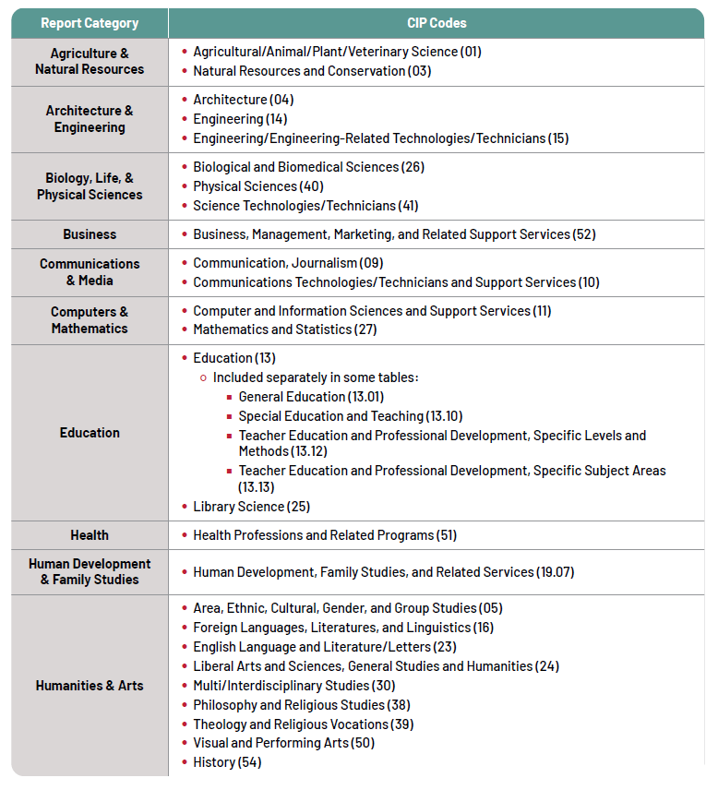
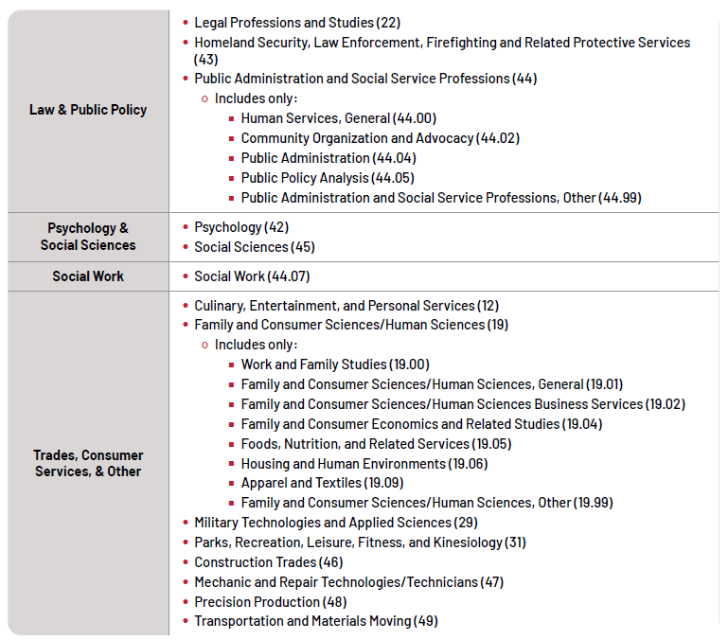

Nonearnings Value Methodology
We use data from the 2016/20 Baccalaureate and Beyond Longitudinal Study (B&B) that capture students who earned a bachelor’s degree in the 2015–16 school year, approximately four years after graduation. These data are used to calculate the share of respondents reporting eligibility for health insurance, paid time off, or retirement plans, as well as the share of respondents who report satisfaction with work–life balance, benefits, job security, and compensation. Satisfaction is measured on a three-point scale, where 1 = dissatisfied, 2 = neither satisfied nor dissatisfied, and 3 = satisfied. Results are reported as the share of respondents indicating satisfaction.

Data from the 2012/17 Beginning Postsecondary Students Longitudinal Study (BPS) capture students from postsecondary entry in 2011–12 through their education and career paths over the subsequent six years. These data are used to calculate the percentage of undergraduate completers six years after entry who report eligibility for health insurance, paid time off, and retirement plans.

Field of Study Categories
To align with the earnings analysis where possible and to simplify categories, we combined several B&B and BPS fields of study. We report outcomes using the consolidated categories below.

Table 5. Field of Study Categories for Nonearnings Outcomes
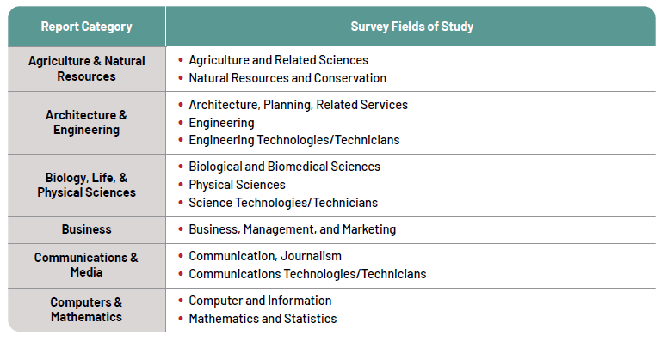
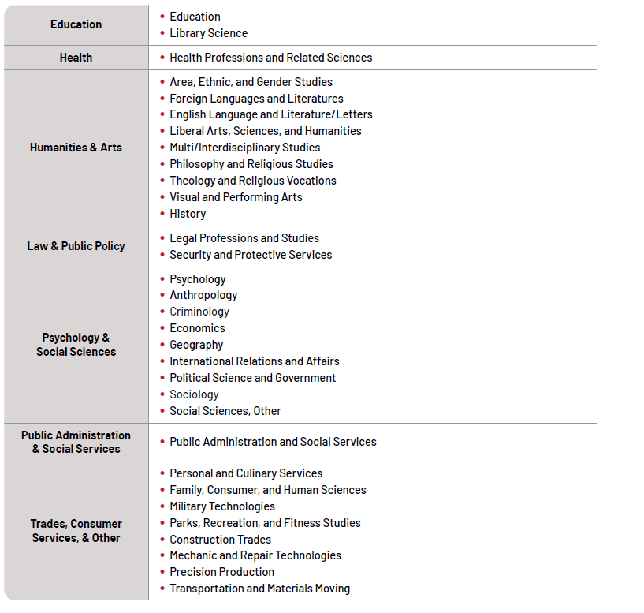

Notes

Diane Cheng, “New Accountability Framework Will Help Ensure Higher Education Provides Strong Outcomes for All Students,” Institute for Higher Education Policy, August 28, 2025, https://www.ihep.org/new-accountability-framework-will-help-ensure-higher-education-provides-strong-outcomes-for-all-students/
Postsecondary Value Commission, “Introducing the Equitable Value Explorer,” https://www.postsecondaryvalue.org/
See Table 4 for details on how CIP codes are grouped into field categories. To view results for individual two-digit CIP codes, visit our data dashboard.
Note that results on graduates’ nonearnings benefits, which come from B&B and BPS study data rather than the College Scorecard, use a slightly different field categorization system.
Academic year cost information is needed to calculate Threshold 0, but not the OB3 earnings premium, which leads to different denominators across these calculations. For-profit programs and certificate programs are disproportionately likely to be affected by limitations in cost data. In some cases, these limitations can cause a larger percentage of programs in our analysis to pass Threshold 0 than the OB3 threshold. For more information on this issue, see Side Box 3. Missing Data Between Thresholds.
Academic year cost information is needed to calculate Threshold 0, but not the OB3 earnings premium, which leads to different denominators across these calculations. For-profit programs and certificate programs are disproportionately likely to be affected by limitations in cost data. In some cases, these limitations can cause a larger percentage of programs in our analysis to pass Threshold 0 than the OB3 threshold. For more information on this issue, see Side Box 3. Missing Data Between Thresholds.
Available data at the even more specific six-digit CIP level from the National Student Loan Data System can help shed light on how accurately these categories reflect the earnings of the early childhood education (ECE) programs they contain. In Human Development and Family Studies, overall earnings are likely to be fairly representative of ECE programs, though they probably falsely improve ECE performance at the bachelor’s degree level. In “Teacher Education and Professional Development, Specific Levels and Methods,” typical ECE earnings are slightly lower than average regardless of credential, meaning overall earnings make ECE outcomes appear slightly better than they are. These findings come from IHEP analysis of data from the National Student Loan Data System. Data provided by the Higher Education and Access through Demand-Driven Workforce Pell (AHEAD) Committee, from the Credential-Program Level (CIP6) data file. Graduate earnings include working and non-working Title IV completers who are not enrolled three years after leaving school. See U.S. Department of Education (website), “Negotiated Rulemaking for Higher Education 2025,” https://www.ed.gov/laws-and-policy/higher-education-laws-and-policy/higher-education-policy/negotiated-rulemaking-for-higher-education-2025-2026.
Though it is not included in the current analysis, IPEDS recently began to allow colleges to report room and board costs for students living with family, where previously these costs were assumed to be zero.
Anthony P. Carnevale, Kathryn Peltier Campbell, Ban Cheah, Megan L. Fasules, Artem Gulish, Michael C. Quinn et al., The Monetary Value of Economic and Racial Justice in Postsecondary Education: Quantifying the Potential for Public Good (Postsecondary Value Commission, May 2021), https://live-postsecondary-value-commission.pantheonsite.io/wp-content/uploads/2021/07/PVC-GUCEW-FINAL-7.2.pdf; and Kim Dancy, Genevieve Garcia-Kendrick, and Diane Cheng, Rising Above the Threshold (Institute for Higher Education Policy, June 2023), https://live-ihep-wp.pantheonsite.io/wp-content/uploads/2023/06/IHEP_Rising-above-the-Threshold_rd3-1_print-1.pdf.
Catherine Morris, Ban Cheah, and Jeff Strohl, The Major Payoff: Evaluating Earnings and Employment Outcomes Across Bachelor’s Degrees (Georgetown University Center on Education and the Workforce, 2025), https://cew.georgetown.edu/wp-content/uploads/cew-the_major_payoff.pdf.
David J. Deming, “Four Facts about Human Capital,” Journal of Economic Perspectives 36, no. 3 (2022): 75–102, https://www.aeaweb.org/articles?id=10.1257/jep.36.3.75.
OXFAM and Institute for Women’s Policy Research, Undervalued and Underpaid in America (OXFAM and IWPR, 2016), https://s3.amazonaws.com/oxfam-us/www/static/media/files/Undervalued_FINAL_Nov30.pdf.
Sandy Baum and Lorelle Espinosa, Exploring the Importance of Low Wage, High Social Value Careers (Postsecondary Value Commission, 2021), https://live-postsecondary-value-commission.pantheonsite.io/wp-content/uploads/2021/10/PVC_Espinosa.pdf.
Diane Cheng, “New Accountability Framework Will Help Ensure Higher Education Provides Strong Outcomes for All Students,” Institute for Higher Education Policy, August 28, 2025, https://www.ihep.org/new-accountability-framework-will-help-ensure-higher-education-provides-strong-outcomes-for-all-students/.
Todd Wallack and Danielle Douglas-Gabriel, “Loan Rules Would Gut Aid for Thousands of Low-Paying College Majors,” Washington Post, June 1, 2026, https://www.washingtonpost.com/education/2026/06/01/loan-rules-would-gut-aid-thousands-low-paying-college-majors/.
Postsecondary Value Commission, “Introducing the Equitable Value Explorer,” https://www.postsecondaryvalue.org/.
Baum and Espinosa, Exploring the Importance of Low Wage, High Social Value Careers, https://live-postsecondary-value-commission.pantheonsite.io/wp-content/uploads/2021/10/PVC_Espinosa.pdf; Sandy Baum and Kristin Blagg, “An Earnings Test for Higher Education Risks Diverting Students from Some Meaningful Careers,” Urban Wire (blog), Urban Institute, February 11, 2026, https://www.urban.org/urban-wire/earnings-test-higher-education-risks-diverting-students-some-meaningful-careers; Arnold Ventures, College Accountability and Public Service: Debunking the Teacher and Social Worker Shortage Myth (Arnold Ventures, November 2025), https://www.arnoldventures.org/resources/college-accountability-and-public-service; and Sandy Baum and Kristen Blagg, Supporting Students Choosing High-Value, Low-Wage Occupations (Urban Institute, December 2025), https://www.urban.org/research/publication/supporting-students-choosing-high-value-low-wage-occupations.
Kathryn Palmer, “Layoffs Gut Federal Education Research Agency,” Inside Higher Ed, March 14, 2025, https://www.insidehighered.com/news/students/academics/2025/03/14/layoffs-gut-federal-education-research-agency.
Morris, Cheah, and Strohl, The Major Payoff, https://cew.georgetown.edu/wp-content/uploads/cew-the_major_payoff.pdf.
Institute for Higher Education Policy, “Strengthening the Economic Value Generated by Public Four-Year Colleges,” July 2026, https://www.ihep.org/resources/reports/evs-tool/.
U.S. Bureau of Labor Statistics, “Occupational Outlook Handbook: Social Workers,” updated August 28, 2025, https://www.bls.gov/ooh/community-and-social-service/social-workers.htm; and U.S. Bureau of Labor Statistics, “Occupational Outlook Handbook: Kindergarten and Elementary School Teachers,” updated August 28, 2025, https://www.bls.gov/ooh/education-training-and-library/kindergarten-and-elementary-school-teachers.htm#tab-8.
Tia Caldwell, Jordan Matsudaira, and Clare McCann, How Do College Programs Measure Up Against the One Big Beautiful Bill Act’s New Accountability Standard? (American University School of Public Affairs, October 2025), https://www.american.edu/spa/peer/upload/obbba-accountability_rpt_final.pdf
Baum and Espinosa, Exploring the Importance of Low Wage, High Social Value Careers, https://live-postsecondary-value-commission.pantheonsite.io/wp-content/uploads/2021/10/PVC_Espinosa.pdf.
Baum and Espinosa, Exploring the Importance of Low Wage, High Social Value Careers, https://live-postsecondary-value-commission.pantheonsite.io/wp-content/uploads/2021/10/PVC_Espinosa.pdf; Baum and Blagg, “An Earnings Test for Higher Education,” https://www.urban.org/urban-wire/earnings-test-higher-education-risks-diverting-students-some-meaningful-careers; and Arnold Ventures, College Accountability and Public Service, https://www.arnoldventures.org/resources/college-accountability-and-public-service.
Casey Khánh Nguyễn, Marshall Anthony Jr., Jaime Ramirez-Mendoza, Mayra Nuñez Martinez, Jalil Bishop, Tanya I. Garcia et al., Centering Quality, Centering Equity: Lessons Learned in Increasing Early Childhood Educator Credentials (The Institute for College Access & Success, July 2024), https://ticas.org/student-success/ece-credentialing/.
Caldwell, Matsudaira, and McCann, How Do College Programs Measure Up Against the One Big Beautiful Bill, https://www.american.edu/spa/peer/upload/obbba-accountability_rpt_final.pdf.
U.S. Bureau of Labor Statistics, “Occupational Outlook Handbook: Kindergarten and Elementary School Teachers,” https://www.bls.gov/ooh/education-training-and-library/kindergarten-and-elementary-school-teachers.htm#tab-8.
Jocelyn Salguero and Diane Cheng, “How ED’s Final Accountability and Transparency Rule Will Help Students, and Where It Falls Short,” Institute for Higher Education Policy, July 2, 2026, https://www.ihep.org/how-eds-final-accountability-and-transparency-rule-will-help-students-and-where-it-falls-short/.
Cheng, “New Accountability Framework Will Help Ensure Higher Education Provides Strong Outcomes for All Students,” Institute for Higher Education Policy, August 28, 2025, https://www.ihep.org/new-accountability-framework-will-help-ensure-higher-education-provides-strong-outcomes-for-all-students/.
Strada Education Foundation, “Work-Based Learning,” https://www.strada.org/focus-areas/work-based-learning.
Krysti Specht, Jonathan Payne, Kassandra McGhee, Daniel Minty, and Shannon Sihoe, “Work-Based Learning: From Information to Action,” Jobs for the Future, https://www.jff.org/idea/work-based-learning-framework/.
Lauren Block, Hannah Maxey, Courtney Medlock, Kate Johnson, and Brianna Nielson, Addressing Wages of the Direct Care Workforce Through Medicaid Policies (National Governors Association Center for Best Practices, November 2022), https://www.nga.org/wp-content/uploads/2022/11/DirectCareWorkforcePaper_Nov2022.pdf; and Emmy Liss and Sarah Gilliland, “Building a Stronger Early Childhood Workforce,” New America, February 24, 2025, https://www.newamerica.org/insights/building-a-stronger-early-childhood-workforce/.
Ashley DeMauro Mullins, “Strengthening the Teacher Workforce: Key 2025 Policy Actions in Six States,” ExcelinEd in Action, January 21, 2026, https://excelinedinaction.org/2026/01/21/learn-more-about-how-six-states-took-bold-action-to-strengthen-the-teacher-workforce-in-2025/.
The Institute for College Access & Success, “Make College More Accessible and Affordable,” 2026 TICAS federal policy agenda, https://ticas.org/wp-content/uploads/2026/02/Pell-Grant-Fact-Sheet_TICAS-2026-Federal-Policy-Agenda.pdf.
Congressional Budget Office, Baseline Projections, “Pell Grant Program,” February 2026, https://www.cbo.gov/system/files/2026-02/51304-2026-02-pellgrant.pdf.
Tia Caldwell, “Pell Financing Explained,” New America, August 12, 2024, https://www.newamerica.org/insights/pell-financing-explained/.
National Center for Education Statistics, “Undergraduate Enrollment,” updated May 2023, https://nces.ed.gov/programs/coe/indicator/cha.
Community College Workforce Alliance, “G3 Initiative,” https://ccwatraining.org/tuition-assistance/g3-initiative.
New York State, “Governor Hochul Launches New York’s Free Community College Program for In-Demand Fields,” press release, July 1, 2025, https://www.governor.ny.gov/news/governor-hochul-launches-new-yorks-free-community-college-program-demand-fields.
Carla Fletcher, Allyson Cornett, May Helena Plumb, Anthony Schuette, Lydia Mentzer, and Bryan Ashton, Student Financial Wellness Survey: Fall 2025 Results (Trellis Strategies, March 2026), https://www.trellisstrategies.org/research-studies/student-financial-wellness-survey-fall-2025/.
“Accountability in Higher Education and Access Through Demand-Driven Workforce Pell: Student Tuition and Transparency System (STATS) and Earnings Accountability,” Federal Register 91, no. 75 (April 20, 2026): 21088–21205, https://www.federalregister.gov/documents/2026/04/20/2026-07666/accountability-in-higher-education-and-access-through-demand-driven-workforce-pell-student-tuition.
Institute for Higher Education Policy, “IHEP Leads Coalition of 51 Organizations and Researchers in Comments on IES Redesign,” press release, October 16, 2025, https://www.ihep.org/press/ihep-leads-coalition-of-50-organizations-and-researchers-in-comments-on-ies-redesign/; and Institute for Higher Education Policy, “IHEP Shares Recommendations to Improve College Cost and Value Transparency for Students and Families,” press release, October 24, 2025, https://www.ihep.org/press/ihep-shares-recommendations-to-improve-college-cost-and-value-transparency-for-students-and-families/.
National Governors Association, “State Longitudinal Data Ecosystem,” November 28, 2023, https://www.nga.org/projects/state-longitudinal-data-ecosystem/.
Kate Tromble, “Actionable Strategies from a Federal–State Conversation,” Data Quality Campaign, April 24, 2024, https://dataqualitycampaign.org/actionable-strategies-from-a-federal-state-conversation/.
State of Oklahoma House of Representatives, “Hill Passes ‘Credential of Value’ Bill to Strengthen Workforce Pipeline,” March 12, 2026, https://www.okhouse.gov/posts/news-20260312_1; and Texas Higher Education Coordinating Board, “Ensuring Students Attain Credentials of Value,” May 29, 2025, https://databridge.highered.texas.gov/credentials-of-value/.
Urban Institute, “Understanding College Affordability: Borrowing,” https://collegeaffordability.urban.org/covering-expenses/borrowing/.
Anthony P. Carnevale, Ban Cheah, and Andrew R. Hanson, The Economic Value of College Majors (Georgetown University Center on Education and the Workforce, 2015), https://cew.georgetown.edu/wp-content/uploads/The-Economic-Value-of-College-Majors-Full-Report-web-FINAL.pdf.

