Creating a Culture of Data Use:
A Case Study of the University of North Texas

By Genevieve Garcia Kendrick, Eleanor Eckerson Peters, and Gabrielle Finnie

March 2024

In 2023, the Institute for Higher Education Policy (IHEP) analyzed data from the Postsecondary Value Commission’s Equitable Value Explorer to identify institutions that deliver equitable value. The University of North Texas (UNT), a Hispanic-serving institution (HSI) located in Denton, Texas, is one such school that invests in its diverse student body, provides resources tailored to the needs of first-generation students and students from low-income backgrounds, and has developed the infrastructure necessary to make data-informed decisions that foster strong student outcomes.
Figure 1: UNT Institutional Profile
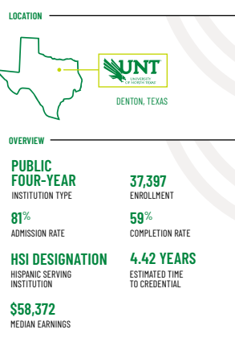
These efforts have paid off for UNT students, 28 percent of whom are Hispanic and 22 percent of whom receive Pell Grants. Between 2016 and 2021, graduation rates at UNT increased from 52 percent to 59 percent, with rates for Hispanic students increasing from 50 percent to 57 percent., Students aren’t just graduating from UNT, but they’re graduating well-equipped for success in the workforce. Ten years after entering UNT, a typical UNT student earns $58,372, exceeding by nearly $17,000 what they would need to earn to break even on their college investment. In fact, students earn roughly the same as the typical bachelor’s degree holder in Texas and enough to reach the fourth income quintile in the state. In other words, UNT is delivering value to its students, setting them up for success in college and beyond.
Students and faculty alike recognize the important role UNT plays in providing value to its students, their families, and the community. Economic opportunities, low cost, and proximity to home draw students like Eghosa Egbenoma, a senior in the kinesiology program, to UNT. As Egbenoma says, “UNT is one of the most affordable universities in the state of Texas. [And] I come from a single parent household, so I needed [to be] close to home in case my mom or my siblings needed anything.” After graduation, Egbenoma is confident his degree in kinesiology will open multiple career pathways that will offer economic stability and a return on his investment. As Professor of Psychology Calvin Sims told us, “When you graduate with a UNT degree, you have the potential to go extremely far in your career.”
To help Egbenoma and all members of UNT’s student body achieve their post-college goals, the university has worked to improve affordability, retention, and completion, which are essential components of increasing postsecondary value. Neal Smatresk, who became UNT’s president in 2014, has made it a priority to provide targeted and equitable support for students, saying, “as a first gen[eration] student myself, there was a lot I didn’t know about college and the job market. It is essential for [UNT] to bolster economic equity by closing graduation gaps.”
Nearly 10 years ago, President Smatresk and UNT leadership recognized that delivering postsecondary value by helping all students graduate and strengthening connections between college and the workforce would require a change in their data infrastructure. Stakeholders throughout the institution would need easy access to timely, relevant, and sophisticated data—data that facilitate student-centered decision-making and support strong postsecondary outcomes. With substantial and ongoing investments of time, money, and energy, UNT launched Insights, a multi-phase, cross-campus project that is transforming the university’s fragmented data system into a robust data infrastructure and simultaneously developing a culture of using data to understand and improve student outcomes.

Figure 2: UNT Snapshot

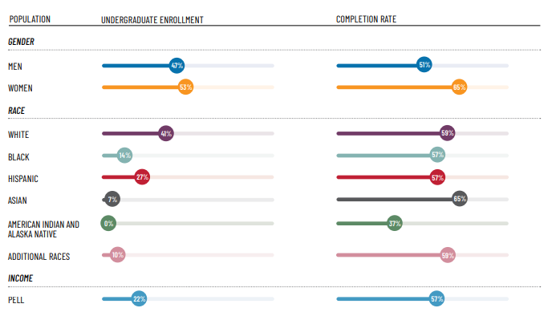
Source: Equitable Value Explorer from January 4, 2023. https://equity.postsecondaryvalue.org/datatool/institution/227216

[Sidebar] About this Case Study
This case study draws on insights gleaned from conversations during the summer and fall of 2023 with administrators, staff, faculty, and students at UNT. Interviewees included University President Neal Smatresk and Associate Vice President for Data, Analytics, and Institutional Research (DAIR) Jason Simon, who are key members of the Insights leadership team. We also spoke with Senior Vice President of Academic Affairs and Provost Michael McPherson; Dean of the College of Science John Quintanilla; Vice President of Strategy and Planning and Chief of Staff Debbie Rohwer; Associate Professor of Psychology Calvin Sims; Assistant Vice President of Financial Aid Beth Tolan; Senior Vice President of Student Affairs Elizabeth With; and students Eghosa Egbenoma and Nicholas Durham, both seniors at the time.

IHEP also conducted desk research, which included reviewing internal documents shared by UNT—including the Insights Project Charter, the SAS post-project white paper, and data training materials—as well as publicly available materials like strategic plans, the president’s annual addresses, and annual data reports.

Our analysis of these materials and qualitative interviews revealed the key strategies UNT used to develop a robust data system and promote a culture of data use—strategies that can be adapted by other institutions seeking to enhance their capacity to equitably deliver postsecondary value for their students and communities.

[End sidebar]

[Sidebar] UNT as an HIS

Through advocacy efforts and increased Hispanic student enrollment, HSIs were formally recognized as a designation in the 1992 Higher Education Act. This federal designation made HSIs eligible for grant funding to strengthen institutional programs, facilities, and services for Hispanic students. There are 571 HSIs nationwide, 101 of which are in Texas, making it the state with the second-most HSIs in the country. UNT was designated an HSI in 2020 and has embraced its designation by creating an inclusive campus environment and serving Hispanic students well. UNT created a Hispanic Serving Institute (HSI) Initiative and Task Force to champion programs and resources to aid Hispanic students in successfully enrolling, matriculating, and graduating from the university. These include a Latino Alumni Network, a Hispanic residential community, Latinx Student Experience (LSE) workshop, and a Spanish Language Parents' Academy.

Additionally, UNT belongs to organizations such as the Texas Association of Chicanos in Higher Education (TACHE) and Hispanic Association of Colleges and Universities (HACU), which seek to improve educational and employment opportunities and increase success for Hispanic students in higher education. As a member of these organizations, UNT receives institutional development and advocacy support, and students can receive scholarships and internships. UNT’s efforts to foster Hispanic student success are making an impact, helping more Hispanic students graduate, and increasing the value they receive from their postsecondary education.

[End sidebar]

Steps for Developing an Integrated Data Infrastructure and Culture of Data Use
From the outset, UNT leadership understood that the Insights project would be an investment of time, money, and staff resources. UNT used seven steps to launch this work, from understanding what its data needs were to launching a second and more sophisticated iteration of the platform.
- Identifying the Need
The UNT System Strategic Plan 2012–2016 required the university to “create a data driven culture that focuses on continuous improvement [and] achieves exceptional service and value for all customers including students.” The plan called for establishing a data warehouse that would help UNT: (1) commit to proactive, informed, data-driven decision-making; (2) improve the availability and visibility of data; and (3) implement new and enhanced visualization tools and techniques for planning and forecasting.
President Smatresk championed launching the initial project, the Data Modeling and Phase 1 Analytical Dashboard Deployment: Insights Program. President Smatresk wrote, “Once it is fully realized in the coming years, the Insights Program will:
- Better track retention analysis, academic progression, and degree patterns.
- Show patterns of student strength and challenge.
- Combine data into readily consumable dashboards for grant and research proposals.
- Make it easier to track areas for collaboration, shared research interests, etc., for teaching, research, and service.
- Provide peer analysis and nationally comparable data for benchmarking at the university, division, and department level.”
Associate Vice President for Data, Analytics, and Institutional Research (DAIR) Jason Simon said, “the president really took on the role as executive sponsor, embraced it, and empowered the organization to think differently about how to utilize data and analytic maturity.”
When the program launched, UNT recognized that building a data-rich campus would be essential for helping all UNT students complete and for delivering postsecondary value.
- Assembling a Team
With an initial investment of $2.1 million, UNT launched the Insights project. President Smatresk recognized that maximizing the university’s investments would require assembling the right team of campus stakeholders. Planning was strategic and collaborative. Jason Simon led a 51-member planning team that included leadership, staff, subject matter experts, and functional data users, separated into 15 working groups tasked with engaging on different project components. For example, he included the decision-makers, executive sponsors, and steering committees; the program workgroup tasked with developing the practical strategies for implementation; and the data stewards who ensured the security and accuracy of student data.
President Smatresk prioritized collaborative decision-making with the explicit goal of breaking down silos. Senior Vice President of Student Affairs Elizabeth With said, “There's been a concerted effort in the last 13 years for…collaborations to exist,” since the president “says openly, ‘I want you all to work as a team. I do not want these to be decisions that are made in a vacuum.’”
- Developing the Insights Charter
In early 2016, the Insights team began developing a charter to lay out the justification, importance, and planning process for developing the new data infrastructure. Insights was not the university’s first attempt to create a comprehensive data tool, but the goals for this effort were broader and more intentional. It aimed to ensure campus data users and policymakers could access the information they needed to make decisions that can improve student outcomes. This project differed from previous endeavors because it “wasn’t just about the data visualization tool, it wasn’t just about plugging in something that was provided already,” Simon explained. Instead, it was about developing a tool that would fit UNT’s specific data-use needs, a tool that would ensure comprehensive data were easily accessible and would foster a culture of data use among campus stakeholders. The Insights team developed the charter to research and articulate UNT’s data needs before deciding the technical aspects of a data system.
Two of the needs outlined in the 2016 charter are (1) to reduce the time necessary to compile useful data and (2) to reduce the number of ad-hoc data requests made of the DAIR team. Accomplishing both would enable DAIR resources to be reserved for high-priority, high-value, and higher-level analytical needs. The data platform had to be easy to access and navigate and users needed training. Instead of flooding DAIR staff with individualized requests, data users would be empowered to pull and analyze data at will and on their own, to make vital, data-informed decisions.
- Engaging the Campus Community
UNT leadership recognized the importance of engaging the campus community in the early stages of the project to lay the groundwork for a culture of informed data use on campus, which was pivotal to the overall success of the tool. Before any technical planning began, the Insights team had to understand the needs of various campus stakeholders who would use the data, so it engaged faculty, staff, and administrators in order to inform the data infrastructure’s design.
UNT wanted to address the challenges data users identified with the current system. Simon partnered with faculty in the Department of Anthropology on a study that would report on the state of UNT’s data-use culture. The researchers interviewed 40 campus participants, including department chairs, deans, vice presidents, and the chancellor of the UNT system. They conducted a thematic analysis of critical pain points that could be addressed with an analytic solution and found four main issues: data documentation, data governance, data maturity, and data trust.
The DAIR team then built an assessment tool called the Data Frustration Index (DFI), which asked subject matter experts and data users about their experiences accessing and utilizing data at UNT. Using the DFI created what Simon calls a “cultural groundswell of understanding that everyone prior to that conversation, everyone had some level of frustration.” The frustrations were different—not knowing where to find data, not knowing who to ask for help, seeing conflicting data—but the DAIR team used those findings to create a numeric scoring system. And this airing of frustrations legitimized the effort by acknowledging current challenges and sharing how the functionality of the new tool would address these frustrations. Using these findings, the Insights planning team began developing a data infrastructure that would serve the university’s needs.

- Identifying a Software Provider
After these steps to understand the university’s data needs, the Insights team sought the external data analytics software vendor and partner that would help it achieve its goals. As Simon explains, “The program charter really guided how we solicited RFPs [request for proposals] for software vendors. Because of the holistic nature of what we were trying to achieve, we needed a vendor that was able to handle the data science applications, the data visualization applications, the data governance applications, and the federation or democratization of data applications.” With these technical needs in mind, amongst many RFP respondents, UNT selected SAS as their external partner and software provider.

- Launching the Insights Data Platform
The first iteration of the data platform, called Insights 1.0, officially launched in 2018. The DAIR team created training materials focused on what UNT calls data literacy, to help users navigate the Insights dashboards and learn the fundamentals of intentional data use. Seeing opportunities to increase efficiency and enable data forecasting, the team updated the platform in 2020, to what is now called Insights 2.0 (Figure 3). The upgraded system includes AI assistance, data modeling, and drop-down menus that allow for disaggregated data. It also significantly improved data visualization and reporting. As of 2023, the platform consists of 28 data dashboards that allow trained users to access analytics about enrollment, admissions, grades, financial aid, student demographics, retention, and completion.

Figure 3: User View of “Undergraduate Students Graduation Rates and Years to Degree” Insights 2.0 Dashboard
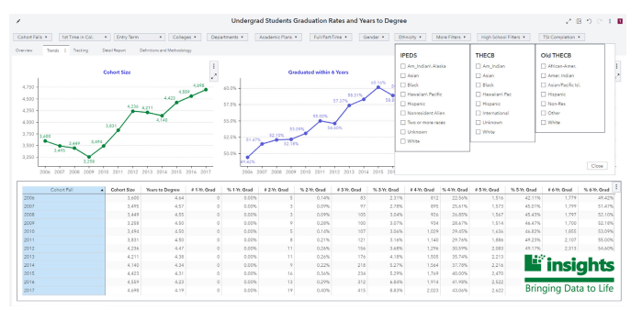
Source: Shared with IHEP by UNT on August 28, 2023
- Supporting Data Users
After the DAIR team launched Insights 2.0, it focused on developing and disseminating the tools data users across campus would need to move from what the team called data agnostic to data literate (Figure 4).
Figure 4: UNT DAIR Insights 2.0 Training Materials
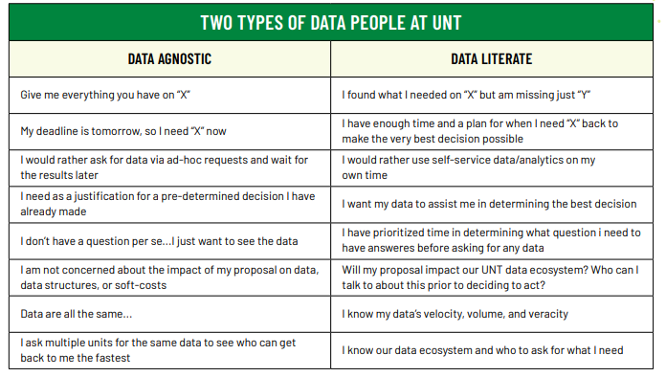
Source: Shared with IHEP by UNT on August 28, 2023.
As of 2023, there are 1,200 trained Insights users across UNT. These users include administrative assistants, faculty members, department chairs, deans, assistant vice presidents, and cabinet members. DAIR offers specialized training throughout the year to accelerate the adoption and use of data, especially among key populations such as new hires and department chairs. Insights training materials explain that the intent of the platform is to answer questions like:
- What really is data?
- How does data move through the organization?
- What are questions that users should be considering when they're looking for data?
- How do we turn a so-so data question into a great data question?
Each training workshop is tailored for attendees’ needs. Departments collaborate with DAIR to structure workshops based on their goals and needs.
It took time, money, and staff resources as well as thoughtful planning to develop the Insights platform—a multi-dashboard data infrastructure used by stakeholders across campus to make data-informed and student-centered decisions to deliver equitable postsecondary value. With a commitment to continuous improvement, UNT has used the Insights project to help build a culture of data use.
Quote: “Will I be able to own an apartment in a nice place and pay my car note and pay insurance and internet and phone bills and all of that stuff? Whether or not I’m able to do that competently and consistently while paying back my debt is [what] I would say is the marker of whether or not any of this was worth it.” —Nicholas Durham, UNT senior
Using Insights to Promote Postsecondary Success for UNT Students
The fragmented nature of UNT’s previous data system meant data users were limited to asking and answering basic questions about student progression and outcomes—and even that could prove challenging. If administrators, faculty, and staff wanted to answer a more complex question, they had to submit a request to DAIR. That meant timely decisions were not necessarily data-informed decisions. Since launching Insights, Simon has seen a drastic change in the use of timely data in the day-to-day work of UNT faculty, staff, and administrators. He observed:
I'm seeing a difference in meetings in the way data is being talked about. Someone will ask a question and say, "Hey, well, I'll just pull up Insights real quick and we'll have an answer." That is a very different culture than what existed before. They’d call DAIR but have to wait until someone picked up the phone or [responded to] an email. Then someone had to do some back-and-forth communication, because usually the question that's asked [isn’t] the question that's really wanted. By the time you actually get data back, it's been a week, and the committee has already moved on and the whole need sort of passed.
Within a few years, Insights has dramatically reduced the number of these requests DAIR receives. The team saw self-service analytics taking hold as stakeholders used the platform to better serve UNT students.
Quote: “The data is just data; that's not going to change your institutional outcomes, just by having data. It's having literacy around the data. It’s having people all know how to understand what data means. Before you'll get access to our Insights products, we're going to put you through an HR-hosted bridge training that exposes our faculty and staff community to principles of good data literacy.” —Jason Simon, Associate Vice President for Data, Analytics, and Institutional Research

Using Insights to Improve Student Outcomes in the College of Science
The Insights platform—the data available, the ease of access, and the training and support users can access—has facilitated concrete changes in the way the university serves students. Dean of the College of Science John Quintanilla, for example, uses Insights at least weekly, often examining student enrollment and grade distribution patterns, and to better understand the students who attend classes at the new UNT campus in Frisco. As dean, he has used the Insights platforms to make vital, data-informed decisions and policy and practice changes.

Sharing Student Outcomes Data Across Campus
Before Insights, Quintanilla had access to student and course data in Excel spreadsheets, which meant that “it was painful to…ask simple questions like, how are engineers doing in Calculus I?” He explains, “I had to come up with a grade roster for calculus, which [was] in one place. I had to find the student ID number and major, which was in a different place. Then I had to make those two spreadsheets sync to each other. It was a very challenging exercise, because the information I wanted was in many different places.”
Having information about how an engineering student performs in a calculus class helps professors develop targeted and personalized advising, and with Insights, Quintanilla can more easily pull and share students’ final grades across colleges and majors. He also is working with DAIR to access more granular data in real time—like exam grades during the semester. He explains how these data can be used for early outreach to students who are struggling: “If there’s an engineer[ing] major taking calculus and the engineer fails a calculus exam, we'll tell the engineering advisors so that they can talk to the student.” Because of the relationships DAIR has built, Quintanilla and all faculty and staff at UNT can recommend changes to the Insights dashboards and know their suggestions will be taken seriously.
Using DFWI Rates to Increase Student Success
Prior to Insights, drop, fail, withdraw, or incomplete (DFWI) rates were calculated by hand, using clunky Excel spreadsheets. The time and effort necessary to organize and use the data meant it was nearly impossible to have consistent data spanning several semesters. Insights made these data more readily available and allowed Quintanilla to identify that the lab courses for anatomy and physiology had exceedingly high DWFI rates. Through additional investigation, including conversations with professors, Quintanilla realized that students needed touch points before the first exam and the midterm exam. This change in pedagogy, informed first by the Insights data and then via conversations with instructors, was made to ensure students understood what would be covered on those exams. When the changes were implemented, the college saw a 20 percent reduction in DFWI rates in these courses. Lowering DFWI rates helps to retain students, ensure students are not wasting vital financial aid money on having to repeat courses, and increase student completion.

Quote: “For me, [delivering value is about] making sure that we have done a really good job in helping our students complete their degree in a timely fashion, not waste their time, [and] not having semester upon semester of either withdraws or fails.” —Beth Tolan, Assistant Vice President of Financial Aid
Using Course Data to Support Student Success
Quintanilla also uses Insights to make choices about how the College of Science can best support students’ persistence and progression. Grade distribution data, for example, showed that a student who received a C grade in Calculus I was less likely to pass Calculus II. With this information, Quintilla is collaborating with faculty members to develop an intermediate course that will bridge the two calculus courses. Progressing at a slower pace helps students gain the knowledge and skills necessary to successfully pursue their major. Insights 2.0 data also showed that if students took First-Year Seminar, they were much more likely to stay enrolled. Quintanilla used this information to justify keeping this seminar for incoming students amid calls for its discontinuation.

The Insights data helps Quintanilla understand who is enrolled in classes at the Frisco campus. Students there attend mostly part-time, which will impact the College of Science course offerings. Quintanilla is also interested in understanding whether Frisco students live near the campus or if they commute long distances to enroll in required courses unavailable on campuses closer to their homes. While Insights cannot answer questions about student motivations, Insights data, paired with planned student focus groups, can reveal ways the university can support academic success.
Improved Outcomes for UNT Students
Using Insights to make the types of policy and practice changes made by the College of Science described here have contributed to improved student outcomes across the university. At the end of its Insights 2.0 contract, SAS released an outcomes report that concluded that Insights helped UNT “enroll the largest number of students (44,500)” and “award the highest number of degrees in one year (10,500).”

According to publicly available data, the university’s six-year graduation rates increased from 52 percent in 2016 (prior to Insights) to 59 percent in 2021 (after the launch of Insights 2.0)., While access to data through Insights is crucial for supporting student success, the culture of data use and the transparency associated with that data use is key to achieving these results. As Quintanilla explains, with this more robust data, faculty and advisors “get into real conversations [with students] as opposed to putting up a front,” adding, “that's a good thing that is not [as easily] measurable.”

Strategies for Success
UNT used three strategies to transform its fragmented data infrastructure and build a culture of data use that supports data-informed and student-centered decision-making:
- Invest in building the data infrastructure and a culture of using data to improve student outcomes
- Engage data users in the development of data infrastructure and its continuous improvement
- Determine data needs before engaging external partners
Strategy 1: Invest in building the data infrastructure and a culture of using data to improve student outcomes
Leveraging the goals of the UNT System Strategic Plan 2012–2016 allowed UNT to prioritize investments in data-informed decision-making. UNT understood that a long-term and multi-step project like Insights requires substantial investments of funding, staff time, and other resources to succeed. And consistent leadership focused on data use to improve student outcomes is key. As Debbie Rohwer, vice president of planning and chief of staff, explains, “I do think continuity, not just with the president, but with many of the VPs, has helped with having conversations and not letting them go. We keep returning to them. When you do that, you want to improve things and not just look at the same challenges. We have a board in our office of the North Stars that always are important—student success and student retention are two.”

President Smatresk agrees, saying, “You need slow, steady, and consistent pressure to build a culture that can pay off over time.” With consistent leadership and investments of financial and human resources, UNT has created a comprehensive and sustainable data project that has placed equal weight on the technical data infrastructure and on the culture of data use—all with an eye towards continuous improvement and supporting student success.

[SIDEBAR] WHAT IS “POSTSECONDARY VALUE”?
The Postsecondary Value Commission, a national group of 30 leaders representing colleges and universities, policymakers, advocates, researchers, the business community, and students, was formed in recognition of the fact that while postsecondary education is a key path to economic and social mobility, various problems (the increasingly high cost for students, inequitable access to institutions and programs, completion rates that are still too low, differences in educational quality and supports, and disparities in post-college outcomes and debt load) were putting this route out of reach, especially for students of color and students from low-income backgrounds. In 2021, the commission issued a framework for measuring postsecondary value (Figure 5) and the following definition of postsecondary value: Students experience postsecondary value when provided equitable access and support to complete quality, affordable credentials that offer economic mobility and prepare them to advance racial and economic justice in our society.

Figure 5: Postsecondary Value Threshold Framework
0 | Minimum Economic Return: A student meets this threshold if they earn at least as much as a high school graduate plus enough to recoup their total net price within ten years.
1 | Earnings Premium: A student meets this threshold if they reach at least the median earnings in their field of study, which accounts for expected variations in pay across fields.*
2 | Earnings Parity: Informed by the University of Texas System’s research on in-field pay inequities, this threshold measures whether students of color, students from low-income backgrounds, and women meet the median earnings of their more advantaged peers (White students, high-income students, or men).**
3 | Economic Mobility: Informed by Opportunity Insights’ measurement of economic mobility across institutions, this threshold measures whether students earn enough to enter the fourth (upper middle) income quintile regardless of field of study.
4 | Economic Security: While sufficient earnings can create a stable life, wealth is key to building the type of security needed to withstand life’s financial shocks, so this threshold measures whether students reach median levels of wealth.
5 | Wealth Parity: Mirroring the earnings parity threshold, this threshold measures whether students of color, students from low-income backgrounds, and women reach the level of wealth attained by their more privileged White, high-income, or male peers.

Notes: Thresholds 0–3 are estimated by using College Scorecard data, with some limitations. Institutions and systems can apply these thresholds with greater detail and specificity if they have the data and analytic resources available. Thresholds 4–5 stand as conceptual goals rather than operable analyses because of the lack of quality data available to measure wealth. This figure highlights the economic value that UNT provides to its students relative to multiple earnings thresholds that reflect the economic circumstances in the state of Texas. Source: Equitable Value Explorer from January 4, 2023.

*If data for field of study are not available, the framework then uses the most predominant degree level (e.g., median earnings among associate’s degree holders). This can be calculated by using pooled 5-year American Community Survey data.

**Available public data do not currently support the production of this threshold for students from low-income backgrounds.

Measuring Value
To help policymakers and practitioners measure the economic returns that come from education after high school, the Postsecondary Value Commission developed a series of six thresholds that measure how and how much better off students are after having attended college. The Postsecondary Value Threshold Framework, as shown in Figure 5, accounts for everything from minimum economic returns, earnings premiums, earnings and wealth parity, and economic mobility and security. The Equitable Value Explorer enables institutions to assess how their median earnings measure against each of the thresholds, and gain clarity on how groups of students—particularly students of color, students from low-income backgrounds, and other historically underserved populations—are and are not meeting these measures. Examining how institutions, programs, and groups of students fare against these measurements can inform institutional efforts to increase economic and noneconomic value for students and promote equitable outcomes.

How UNT Performs on the Economic Value Thresholds
The Equitable Value Explorer shows that UNT provides strong economic outcomes for its students. The institution performs particularly well on two of the measures, Threshold 0 and Threshold 3, and nearly meets Threshold 1.

Ten years after initial enrollment, a typical UNT student earns $58,372. This is nearly $17,000 ($16,642) above Threshold 0, a measure of the median earnings of high school graduates in Texas, plus a measure of their investment in their postsecondary education. UNT’s median earnings also exceed Threshold 3, meaning the typical UNT student earnings exceed the 60th percentile of earnings for prime age workers in Texas.

Threshold 1 measures whether students reach median earnings for others with similar credentials. UNT median earnings are just $120 shy of meeting this threshold. While many factors contribute to performance on the thresholds, improving graduation rates and strengthening connections to the workforce could boost median earnings enough to surpass Threshold 1. For example, the median earnings figure includes both completers and non-completers—those students who enroll but do not complete and therefore likely don’t receive the bump in earnings associated with holding a four-year degree. If UNT graduates a greater share of its student body, median earnings will likely also rise. Strong connections between the university and businesses can also ensure students graduate with skills that are in demand.

Figure 6: Overall Economic Value Thresholds

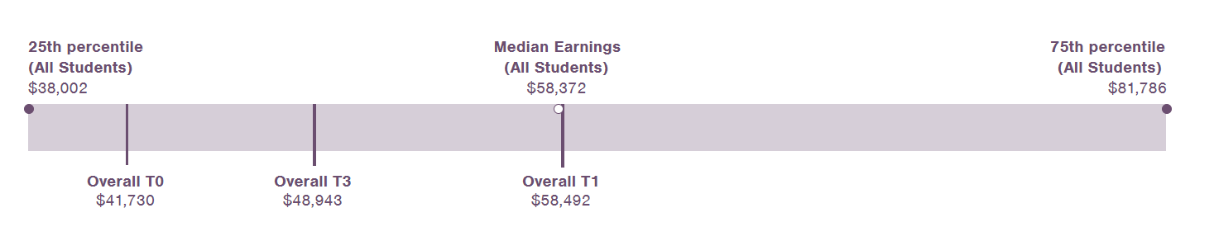

Strategy 2: Engage data users in the development of the data infrastructure and its continuous improvement
UNT strategically engaged individuals from across campus to develop Insights and ongoing training. This engagement fostered buy-in and trust among Insights users, laying the foundation for a strong culture of data use and ongoing engagement in the continuous improvement of the platform. As Quintanilla explains, “It's a matter of being able to put the data in front of users so that somebody who's not a specialist in data analytics can be able to hopefully make reasonable decisions from it. There's certainly a lot of questions that I can't answer with Insights yet, but the good thing is that the Insights teams know my questions. As the product evolves, they're very good at seeking feedback from users.” UNT seeks to create a data system that leads to positive changes for students. Simon says, UNT is “trying to make data democratization a reality by eliminating barriers” to help decision-makers on campus deliver strong student outcomes.
With the improvements made between Insights 1.0 and Insights 2.0, Simon and the DAIR team are now looking towards the future of machine learning. UNT hopes to forecast and model possibilities for student retention and completion. Having timely, robust, disaggregated, and complex data will allow UNT to ask even more sophisticated questions about student outcomes and use those analyses to make data-informed decisions.
Strategy 3: Determine university needs before engaging external partners
UNT sequenced the development of Insights by first engaging campus data users to understand their needs and then engaging potential external partners. Before reaching out to software providers, DAIR assembled a team of stakeholders, conducted studies to thoroughly understand their various needs, and wrote a comprehensive project plan and charter that outlined its goals. Because UNT took the time to align internally, when it came time to develop an RFP, DAIR could clearly articulate what it needed in a software provider. Vendors and external partners who responded to the RFP could respond to those specific needs and shape a platform appropriate for UNT. This process, although time-consuming and laborious, paid off in the end.

Recommendations for Advancing Equitable Postsecondary Value on Your Campus
As summarized in this case study, the strategies employed by UNT to build an infrastructure and culture that supports student-centered and data-informed decision-making offer three important takeaways for institutions looking to engage in similar work.

- Use data to inform equitable decision-making.
To create change that delivers greater equitable postsecondary value, like improving completion rates or shortening time to degree, institutions must examine disaggregated data to understand inequities and inform policy and practice changes. Institutional leaders should create a culture in which all decision-makers on campus take a data-informed, student-centered approach to all that they do.

- Engage all stakeholders to understand data needs.
The key to creating a culture of data use is understanding an institution’s data needs. At UNT, this included transforming the university’s fragmented data system into a robust and easy to access infrastructure and developing training materials to support its use. To understand the needs on their campuses, leaders should engage diverse stakeholders at all levels to identify areas for improvement and collaborate in the planning and execution of data projects. Including data users and decision-makers in this way can ensure investments in data tools are realized, which builds champions across campus for using data to improve student outcomes and increase equitable postsecondary value.

- Invest in tools, systems, and/or culture that meet institutional needs.
Campus transformation is slow and requires committed leadership as well as investments of time, staff capacity, and money. For those investments to translate into equitable postsecondary value, institutions should invest in planning to develop the foundations for successful implementation and sustainable continuous improvement.
Acknowledgements
This research was funded by The Annie E. Casey Foundation, Inc., and we thank them for their support; however, the findings and conclusions presented in this report are those of the authors alone, and do not necessarily reflect the opinions of the Foundation.
We would like to thank all the IHEP staff who helped in this case study, including Mamie Voight, president and CEO; Kelly Leon, vice president of communications and government affairs; Diane Cheng, vice president of research and policy; Lauren Bell, communications associate; Kimberly Dancy, associate director of research and policy; Charles Sanchez, research analyst; and Jaden Mikoulinskii, former research intern. We are very grateful to the staff and students at University of North Texas who lent their time for interviews with the IHEP team. We also thank Lauren Asher, IHEP consultant, for her subject matter expertise, Sabrina Detlef for copyediting and openbox9 for creative design and layout.

Endnotes

Postsecondary Value Commission (website). Equitable value explorer. UNT EVE Data. https://equity.postsecondaryvalue.org/datatool/institution/227216
National Center for Education Statistics (NCES). Graduation rates, status as of August 31, 2018. https://nces.ed.gov/ipeds/datacenter/FacsimileView.aspx?surveyNumber=8&unitId=227216&year=2016
National Center for Education Statistics (NCES). Graduation rates, status as of August 30, 2021. https://nces.ed.gov/ipeds/datacenter/FacsimileView.aspx?surveyNumber=8&unitId=227216&year=2021
Higher Education Act of 1992, Pub. L. No. 102-325. https://www.congress.gov/bill/102nd-congress/senate-bill/1150
University of North Texas Office of the Provost (website). Hispanic Serving Institute Initiative. https://vpaa.unt.edu/provost/initiatives/hsi
UNT University Brand Strategy and Communications. (2022, September 14). UNT earns national diversity award for fifth year in a row. https://news.unt.edu/news-releases/unt-earns-national-diversity-award-fifth-year-row; and Harmon, N. (2012, January). The role of minority-serving institutions in national college completion goals. IHEP. https://www.ihep.org/publication/the-role-of-minority-serving-institutions-in-national-college-completion-goals/
Texas Association of Chicanos in Higher Education (website). https://www.tache.org/about
Hispanic Association of Colleges and Universities (website). https://www.hacu.net/hacu/HACU_101.asp
UNT System (website). Internal documents: UNT Board of Regents (2016, August 18). Board of Regents Meeting. Board Book https://www.untsystem.edu/board-regents/meetings/index.php
UNT System. Internal documents: UNT Board of Regents (2016, August 8). Board of Regents Meeting. Board Book.
UNT Internal document: UNT Insights Team. (2016). Insights’ Charter.
UNT (website). Office of the President. (2017, April 28). Next steps for the data warehouse implementation: An official notice from the president. https://www.unt.edu/notices/next-steps-data-warehouse-implementation-official-notice-president.html
UNT Internal document: UNT Insights Team. (2016). Insights’ Charter.
SAS. (2023) University of North Texas Insights Program: From data-rich, information poor to a $37.8 million return on investment.
NCES. Graduation rates, status as of August 31, 2018.
NCES. Graduation rates, status as of August 31, 2021.
Postsecondary Value Commission. Postsecondary Value Commission. (2021, May). Equitable value: Promoting economic mobility and social justice through postsecondary education. https://postsecondaryvalue.org/wp-content/uploads/2021/07/PVC-Final-Report-FINAL-7.2.pdf.

