Believing in the Potential of Every Student: An IHEP Case Study on LaGuardia Community College

Authors: Janiel Santos, Lauren McLeese, Gabrielle Smith Finnie, and Eleanor Eckerson Peters
March 2024
Figure 1.

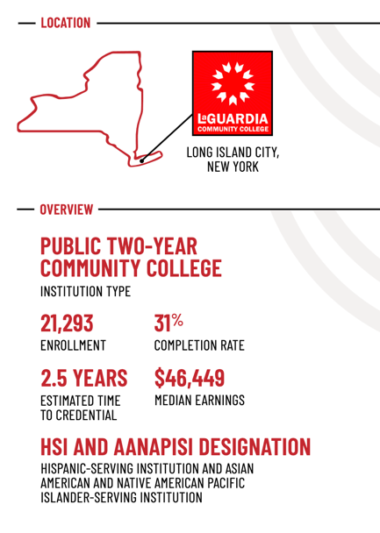
In 2023, the Institute for Higher Education Policy (IHEP) analyzed data from the Equitable Value Explorer to identify institutions that equitably deliver postsecondary value to their students. LaGuardia Community College, a City University of New York (CUNY) institution, stood out as an exemplar. Situated in Queens, New York City’s most ethnically diverse borough, LaGuardia’s mission is “to educate and graduate one of the most diverse student populations in the country to become critical thinkers and socially responsible citizens who help to shape a rapidly evolving society." As part of the nation’s largest urban public university system, LaGuardia plays an important role in opening the doors of opportunity to postsecondary education in its community and helping students and their families attain the better living and better life a college degree affords.
A Hispanic-serving institution, an Asian American and Native American Pacific Islander-serving institution, and community college, LaGuardia enrolls substantial populations of Hispanic (44 percent), Asian (20 percent), and Black (17 percent) students. Additionally, 39 percent of students who attend LaGuardia receive federal Pell grants, a federal financial aid program designed to support students from low-income backgrounds.
LaGuardia has been recognized as an engine of economic mobility, successfully moving students from low-income backgrounds into the middle class and beyond by embracing their varied aspirations. Whether students seek to launch a career, upskill for advancement in their chosen field, or seamlessly transfer to a four-year university, LaGuardia tailors its offerings to fit their individual goals. This student-centered approach, coupled with a deep commitment to postsecondary value, has propelled LaGuardia to the forefront of the Equitable Value Movement– a growing movement in higher education to look beyond equitable access and completion towards ensuring students from all backgrounds receive postsecondary value.
“We have an obligation to students who entrusted us with their college and career education, to someone who's giving us their hard-earned cash or their Pell Grant, and their time, energy, and commitment,” said LaGuardia President Kenneth Adams. “The spirit has to be, ‘everything [is] on the table to help you succeed; we're not done until you get what you came for.’” Since joining the institution in 2020, President Adams and his team have built on former President Gail Mellow’s legacy by ensuring that institutional structures, investments, programs, and policies are designed and implemented in such a way that LaGuardia can help all students achieve their educational and professional goals.
This case study delves into the innovative strategies LaGuardia employs to deliver on its promise of value to students. From bridging the gap between nondegree programs and academic tracks to smoothing the transfer process to four-year institutions, institutional leaders proactively remove obstacles for students so they can chart their own unique paths to success.
[Sidebar] About this Case Study
This case study draws on insights gleaned from conversations during the summer and fall of 2023 with administrators, staff, faculty, and students at LaGuardia Community College. Interviewees included President Kenneth Adams as well as Provost and Senior Vice President for Academic Affairs Billie Gastic Rosado; Vice President for Student Affairs Alexis J. McLean; Executive Director of the Foundation Jay Golan; Vice President for Adult Continuing Education Sunil Gupta; Dean for Institutional Effectiveness Nava Lerer; Vice President for Enrollment Management Benjamin E. Rohdin—all members of the President’s Cabinet. We also spoke with Director of the CUNY Language Immersion Program David Housel; Faculty Chairperson for the English Department Irwin Leopando; Senior Director for Career and Professional Programs Chandana Mahadeswaraswamy; Associate Dean for Academic Affairs Dionne Miller Director of Credit for Prior Learning Marsha Oropeza; Director of First Year Programming & Student Success Ellen Quish; Director of ACE Enrollment Management George Schreiner; Senior Director of Workforce Development Hannah Weinstock; and students Tahlaiya Thompson and Jiamin Wu.
IHEP also conducted desk research, which included reviewing internal documents shared by LaGuardia as well as publicly available materials. Our analysis of these materials and qualitative interviews revealed the key strategies LaGuardia leverages to support students’ success and equitably deliver postsecondary value.
Figure 2.

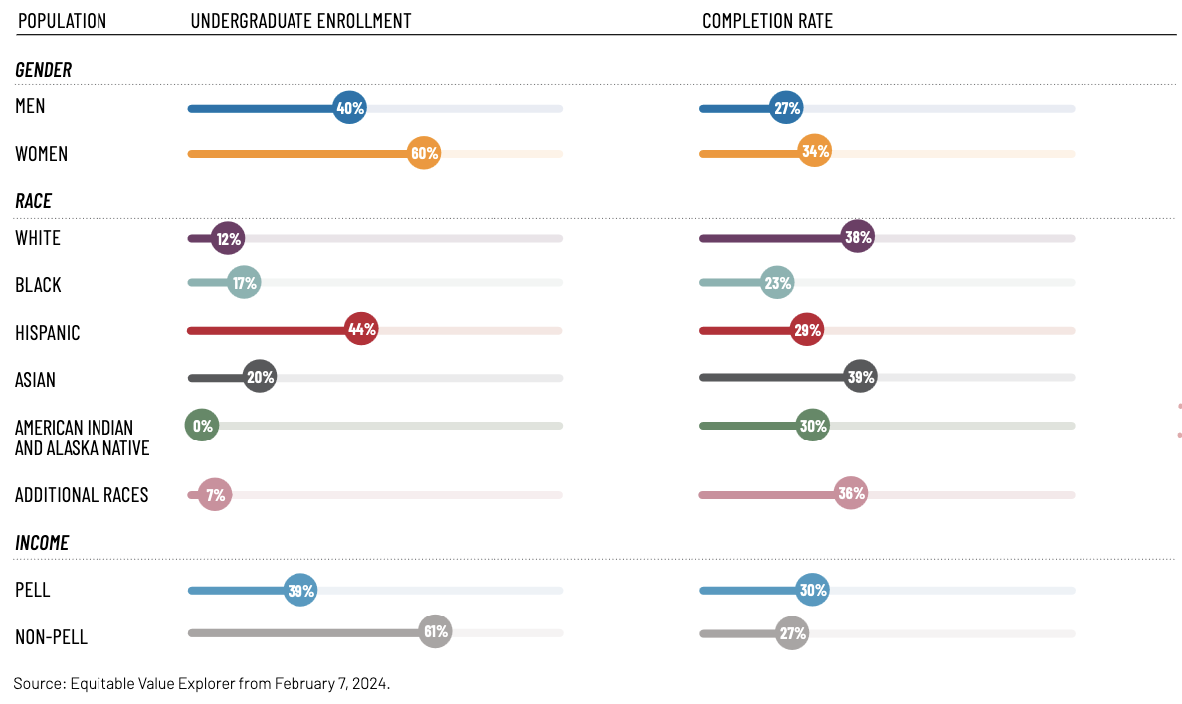

[Sidebar] What is Postsecondary Value?
The Postsecondary Value Commission, a national group of 30 diverse leaders representing colleges and universities, policymakers, advocates, researchers, the business community, and students, was formed in recognition that while postsecondary education is a key path to economic and social mobility, various problems—such as the increasingly high cost for students, inequitable access to institutions and programs, completion rates that are still too low, differences in educational quality and supports, and disparities in post-college outcomes and debt load—were putting this route out of reach, especially for students of color and students from low-income backgrounds. In 2021, the Commission issued the following definition of postsecondary value: “students experience postsecondary value when provided equitable access and support to complete quality, affordable credentials that offer economic mobility and prepare them to advance racial and economic justice in our society.”
Quote: “If we really believe in the potential of each individual student, no matter where they come from and where they want to go, what they want to get out of their LaGuardia experience—[their] whole diverse range of needs and of aspirations—we have to be committed to helping them realize their full potential.” —President Kenneth Adams
[Side Bar] What it Means to be a Minority-Serving Institution
Minority-serving institutions (MSIs) play a crucial role in the higher education ecosystem and Equitable Value Movement. They enroll large numbers of Black, Latinx, American Indian, Asian American, Native Hawaiian, and Pacific Islander students, as well as many students living with low incomes and students who are the first in their family to attend college.
Several types of MSIs, including Hispanic-serving institutions (HSIs) and Asian American and Native American Pacific Islander-serving institutions (AANAPISIs), are federally designated based on student enrollment and institutional expenditure thresholds. In 2021–22, 571 institutions in the United States were designated HSIs, and they enrolled the majority (62 percent) of all Hispanic students nationwide. In 2022, 281 colleges and universities qualified as AANAPISIs. These institutions enroll nearly half the Asian American, Native Hawaiian, and Pacific Islander undergraduate students in the U.S. Because more than 25 percent of LaGuardia students identify as Hispanic and more than 10 percent identify as Asian American, Native American, or Pacific Islander, the college qualifies as both an HSI and an AANAPISI .
“It's significant to be an institution in this community, in Queens in particular, where students know, or prospective students know that they can start something new here or they can achieve a long-awaited goal here without obstacle. Just that connectedness to our local community matters a great deal in terms of our pursuit of equitable outcomes.” —Billie Gastic Rosado, Provost and Senior Vice President for Academic Affairs

Creating Student-Centered Pathways into and through LaGuardia
At LaGuardia, administrators, staff, and faculty understand that students enroll with the intention of developing skills that will help them obtain a job upon completion, upskilling to advance in their careers, or transferring to earn a four-year degree. With more than 50 associate’s degree and certificate programs, and many more nondegree programs housed within the Adult Continuing Education (ACE) division, there is no shortage of options for students hoping to achieve one—or more—of those goals.
This expansive offering matches the diversity of LaGuardia’s student population, which features a range of race/ethnicity, language spoken, field of interest, and personal, professional, and educational experiences. At LaGuardia, 81 percent of undergraduate students are students of color, 39 percent are Pell recipients, and more than half identify as first-generation. More than 133 countries are represented, and 62 different languages are spoken by LaGuardia students.
“Our student demographic is so varied,” said Ellen Quish, director of First Year Programming & Student Success. “In the class that I'm teaching, I have a grandparent, I have student parents, I have professionals, I have students who have physics degrees from their native countries. I have students who [have been] involved with the criminal justice system. It's a real range.”
LaGuardia Community College embraces its institutional responsibility for guiding students along a path that will help them meet their goals—offering supports that can prevent students from getting lost in all the different majors and nondegree programs offered or as life circumstances shift. Its leaders make policy and practice decisions predicated on understanding students’ backgrounds, needs, and aspirations, with the aim of creating clear pathways to academic and workforce success, thereby increasing the value students receive from their education at LaGuardia. Typical students earn approximately $46,500 a year 10 years after entering LaGuardia, which is nearly $7,000 more than what they would need to break even on their college investment and roughly $5,000 more than typical associate’s degree holders in the state of New York. This means that LaGuardia delivers postsecondary value to students, setting them on the path to achieving their varied goals, including attaining financial stability and reaching their career aspirations.
The following section highlights examples of how LaGuardia has designed and implemented policies that enhance students’ academic experience so they can achieve success, however they define it. These examples include:
- setting English language learners on the path to academic success
- building bridges between adult continuing education and degree programs
- adapting curricula to promote student degree completion
- smoothing transfer to four-year colleges
Quote: “You don’t have to figure out whether ‘I want to be a nondegree or degree student.’ You just come and we will help. Most places…there are two different doors you walk in. Here we’re very deliberately starting to try to make that one door so that anybody can be a student at LaGuardia. It’s doesn’t matter what path you’re going to take.” —Benjamin E. Rohdin, Vice President for Enrollment Management
[Sidebar] What is Adult Continuing Education (ACE)?
LaGuardia is home to CUNY’s largest adult continuing education (ACE) division, regarded as one of the country’s most comprehensive programs of its kind. LaGuardia’s ACE division houses a variety of programs designed to serve the needs of the local community, from English language learning programs like CLIP to pre-college, career skills, and workforce development trainings.
As with other ACE programs across the country, LaGuardia’s ACE division functions on a self-funded model, which can limit the kinds of resources, aid, and supports it can provide students. Typically, students in continuing education divisions are not eligible for federal student aid and are not always eligible for institutional aid. However, the LaGuardia Foundation provides scholarships that cover 80 percent of tuition to eligible ACE students. Since 2021, 1,599 awards, or $1,140,447 in student aid, have been made available to students enrolled in ACE programs. This investment in non-matriculated students, in tandem with bridges to matriculation, helps to open doors to students who may initially attend the college for workforce training rather than with the goal of earning a degree.
Setting English Language Learners on the Path to Academic Success
Students come to LaGuardia with varying levels of English language proficiency. LaGuardia’s CUNY Language Immersion Program (CLIP), which is housed within ACE, is an intensive, pre-college, English to Speakers of Other Languages program. The program helps students—based on writing placements or student affairs referrals—improve their English-language proficiency and academic skills so they can matriculate into their desired degree program at LaGuardia.
The CLIP program also supports students through the matriculation process, coaching participants on major selection and potential career trajectories as well as helping address common barriers that can disrupt students’ transition from CLIP into degree programs. David Housel, director for CLIP, said that “most students feel academically prepared enough to matriculate, but often ‘life’ gets in the way with demanding work schedules, medical issues, child care concerns, family obligations and emergencies, including those in students’ home countries, etc.” The team assists with financial aid and scholarship applications, submitting any documentation missing from students’ admission files, and following up with advising, registration, and payment processes as students exit CLIP.
CLIP also provides a safe environment for students to develop strong bonds with peers, staff, and the college that they can carry with them as they transition to degree programs, which boosts academic success, retention, and completion. Jiamin Wu, a former CLIP participant, said, “in the CLIP program, there’s a lot of people in the same situation as me so we didn’t worry about people laughing at our accents or the language. We feel free to talk [in English] even though we did not really know the vocabulary,” and “after one year learning in the CLIP program, I [became] more and more confident to speak out with other people.”

Building Bridges between Adult Continuing Education and Degree Programs
Many students’ first interactions with LaGuardia are through the ACE division. Whether seeking to upskill for a promotion, participate in employer-sponsored training, or acquire valuable life skills, ACE provides a gateway to further learning. Recognizing the potential of these learners to pursue degrees, LaGuardia has invested in building bridges for students between ACE programs and degree programs. Furthermore, restructuring and strengthening pathways between programs housed in the ACE division and degree programs is a strategic move that can help LaGuardia address the enrollment declines that so many community colleges are facing in the wake of the COVID-19 pandemic.
Traditionally, ACE divisions are separate entities from degree-seeking programs. But LaGuardia’s leaders have been diligently building bridges to facilitate easier movement in both directions, allowing students to transition from ACE to degree programs and vice versa. This is evidenced by the fact that “almost 10 percent” of the most recent graduating class originated from the ACE division, as shared by Vice President for Adult and Continuing Education, Sunil Gupta. This model supports the institution’s enrollment, retention, and recruitment recovery efforts and simultaneously encourages students’ educational growth by auditing and restructuring systems that may have unintentionally limited their potential.
Gupta described his work in aligning the ACE division with the direction of other divisions at the college: “all of these different opportunities and engagements with faculty have created what we are calling now at the college, a one college culture.” This means that “all of our opportunities and doors of access to the college lead to…matriculating opportunities for economic stability and success and also non-credit programs,” He said. LaGuardia’s “one college culture” shines through in two key ways for students transitioning from ACE programs to degree programs: (1) coaching and advising from ACE’s Career and Technical Education Assistance (CTEA) office and (2) memoranda of understanding (MOUs) between ACE and degree programs to award academic credits to ACE students.
The CTEA office within ACE helps students navigate the matriculation process. “If you’re an electrical student, for example, and you want to apply to the college, you have [CTEA] that you can work with in ACE,” explained George Schreiner, director of Enrollment Management for Continuing Education. CTEA is able, he said, “to help you apply to the college at the right time and help counsel you and advise you through the process.”
Nondegree students who decide to matriculate into the college—whether immediately after completion of their credential or years later—may be awarded credit for the work they’ve already accomplished within ACE. In addition to offering students credit for prior learning (CPL), Marsha Oropeza, director of Credit for Prior Learning and Dionne Miller, associate dean for Academic Affairs, have been leading the development of MOUs between ACE noncredit programs and degree-affiliated programs. Under these MOUs, students who take specific ACE courses can also earn credit for academic programs should they choose to matriculate into the college. For example, students who pursue the Community Health Worker certificate through LaGuardia’s ACE division would be able to articulate their work towards a degree in Public and Community Health or in the Human Services program.
To ensure alignment in learning goals, MOUs are negotiated between the faculty and staff in both divisions. “It’s not just general elective credit or just blanket credits” that students receive, explained Miller. Students are awarded credit for core program courses, which “really accelerates them towards degree completion,” she said. At the time that IHEP connected with Oropeza and Miller in October 2023, 12 MOUs been established between ACE and academic credit programs, with more in the pipeline. Bridges between ACE certificates or courses with degree program courses help students who choose to matriculate maintain their academic momentum, keeping them on the path to completion.

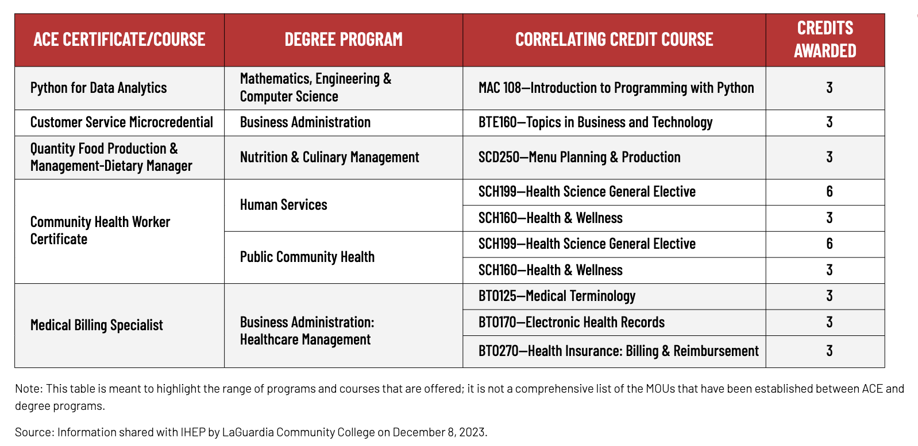
Figure 3: Examples of LaGuardia’s MOUs between ACE certificates/courses and degree programs

Adapting Curricula to Promote Student Degree Completion
LaGuardia smooths pathways within degree programs by identifying and adjusting academic curriculum elements that might unintentionally hinder or disrupt academic progress. Provost and Senior Vice President for Academic Affairs, Billie Gastic Rosado said, “we're looking at, from a curricular perspective, what are the kinds of courses that stand in a student's way to reaching their academic goals?” Recently, the provost and her team identified classes that, in practice, act as weeder courses, with high withdrawal rates, even though there is “no interest in them serving in that role.” Withdrawals can negatively impact students’ persistence, requiring them to use financial aid for repeat coursework and potentially question their ability to succeed in a program of study.
To increase student success in these courses, administrators and faculty in the Health and Sciences department made changes to better support students’ learning and academic success. Additional class hours have been allocated to courses with high withdrawal rates and faculty have redesigned their teaching methods to address diverse learning styles. Gastic Rosado and her team track metrics, including drop, fail, and withdrawal rates, to assess the effectiveness of these modifications.
The ENX-101 workshop offered by LaGuardia’s English department also exemplifies this commitment to student learning and academic progression. This free, three-week intensive "second chance" course offers targeted support to students who narrowly fail Composition I, a course students must pass in order to graduate. ENX-101 helps students get back on track and avoid the setbacks that come with narrowly failing a crucial course, including having their academic momentum derailed, their financial aid depleted, and their sense of belonging jeopardized. Since its launch in spring 2019, the ENX-101 workshop has seen an 89 percent pass rate among students who attended the full course, allowing students to move on to Composition II as early as the following semester without delay. “I think the message you send students,” said Irwin Leopando, chair of the English department and co-creator of the ENX-101 program, is “we believe in you; we want to help you along.” He said, “in a lot of ways, a near miss is more demoralizing than a wide fail,” so “if we can do something to help people who are almost there and not walk away at that point, it helps with retention.”
Smoothing Transfer into a Four-Year College
For many students, community college is a stepping stone to a four-year degree. LaGuardia boasts a strong 40 percent transfer-out rate, ranking high both within the state of New York and nationally. Tahlaiya Thompson, a LaGuardia student enrolled in the Deaf Studies program said, “after my studies, I actually want to go to a four-year college to pursue more American Sign Language interpreting.” Jiamin Wu, the CLIP participant, plans to transfer to Hunter College to pursue nursing after completing her program at LaGuardia.
At many institutions, transfer is a cumbersome and inefficient process, with the U.S. Government Accountability Office (GAO) estimating that nationally, students lose approximately 43 percent of credits upon transfer. “Students might be at a bit of a disadvantage…because they've done the equivalent courses, but they don't all count towards a program core,” explained Miller, associate dean for Academic Affairs. “This is problematic because maybe a student could take a minor if all those courses were actually being applied to their program, but because [they’re] not, some of their credits are going into just their general elective liberal arts buckets.” Repeated coursework costs valuable time, energy, and money.
Recognizing the challenges of credit loss during transfer, LaGuardia works with senior colleges in the CUNY system to establish strong articulation agreements. These agreements streamline the transfer process and mitigate credit loss. The focus in negotiating these agreements is on ensuring LaGuardia credits count as core courses at the transfer institution so students start as third-years upon transfer. By assuming the administrative burden of establishing these agreements with four-year colleges, LaGuardia has increased the value students receive, saving them resources, boosting morale, and helping them maintain academic momentum.
LaGuardia has started this work by focusing on its largest academic programs, therefore facilitating easy transfer for the greatest number of students. Completed articulation agreements are published on LaGuardia’s website, providing transfer students with access to materials that are necessary for advocating for their credit acceptance. While institutional guidance, coaching, and support also is necessary to help students navigate the transfer process, these online agreements provide students with the baseline tools they need to begin the process.

Measuring Value
To help policymakers and practitioners measure the economic returns that come from education after high school, the Postsecondary Value Commission developed a series of six thresholds that measure how and how much better off students are after having attended college. The Postsecondary Value Framework, as shown in Figure 3, accounts for everything from minimum economic returns, earnings and wealth parity, economic mobility and security and earnings premiums. The Equitable Value Explorer enables institutions to assess how their median earnings measure against each of the thresholds, and gain clarity on how groups of students—particularly students of color, students from low-income backgrounds, and other historically underserved populations—are and are not meeting these measures. Examining institutions through the lens of the value framework helps stakeholders understand the overall value students receive from enrolling in an institution or program and can also shed light on outcomes for various student groups.
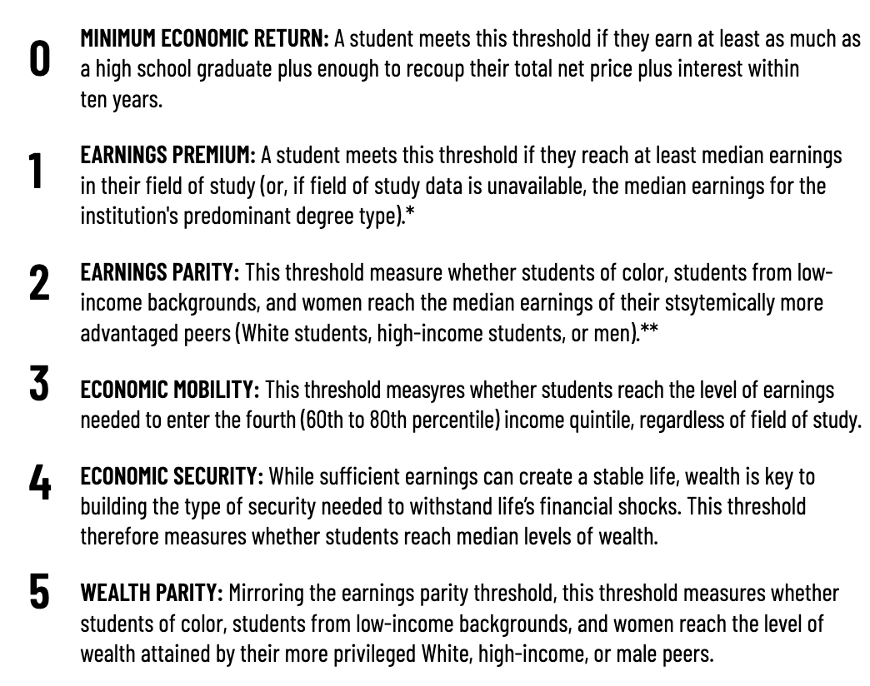
Figure 4: The Economic Value Thresholds

How LaGuardia Performs on the Equitable Value Thresholds
Using the Equitable Value Explorer, an interactive data dashboard that allows users to analyze and compare institutions against the Postsecondary Value Framework, IHEP found that LaGuardia provides strong economic outcomes for its students. The institution performs particularly well on two of the measures—Threshold 0 (Minimum Economic Return) and Threshold 1 (Earnings Premium).
LaGuardia students earn a median income of $46,449, exceeding the minimum economic return—called Threshold 0—by nearly $7,000 ($46,449 vs. $39,677). This threshold represents the amount a LaGuardia student must earn to earn as much as a high school graduate in New York State plus enough to recoup the cost of their education over 10 years. Similarly, LaGuardia students' earnings exceed Threshold 1 by nearly $5,000, exceeding the median earnings for New Yorkers with associate’s degrees. LaGuardia is nationally recognized for its ability to move students from low-income backgrounds into the middle class and beyond, ranking fifth among two-year colleges community colleges for economic mobility, according to a study conducted by the Brookings Institution in 2020.
While the college surpasses Thresholds 0 and 1 with substantial margins, there are opportunities to improve the value it offers students. Threshold 3 measures whether students earn enough to enter the fourth income quintile (60th percentile) or higher in their state. LaGuardia students’ median earnings fall short of this threshold by about $12,000. And while it is common for community colleges’ median earnings to fall below Threshold 3, there are steps LaGuardia—and other community colleges—can take to boost median earnings and increase the value their students receive. Improving graduation rates, increasing affordability, helping students transfer to earn a four-year degree, and strengthening connections to the workforce would all help. For example, approximately seven in ten LaGuardia students do not complete their degree, yet they are included in the median earnings statistic, likely deflating it. By increasing the share of students who complete, more LaGuardia students would reap the higher earnings that typically come with a college credential, and the college’s performance on Threshold 3 would improve.
The Economic Value Thresholds provide an overarching view of LaGuardia student outcomes, revealing both commendable achievements and areas for improvement. These data and the framework can help support LaGuardia’s goal of smoothing academic and career pathways in order to pave the way toward economic mobility for its students.

Figure 5: Overall Economic Value Thresholds

This figure highlights the economic value that LaGuardia provides to its students relative to multiple earnings thresholds that reflect the economic circumstances in the state of New York.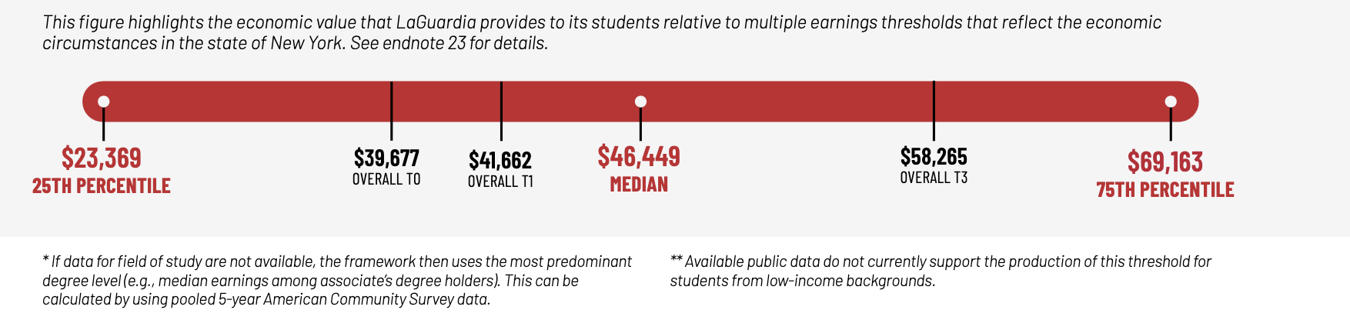

Strategies for Delivering Strong Value to Students
At the center of LaGuardia’s programs, policies, and initiatives stand four core strategies for equitably delivering postsecondary value to students and setting them on a path toward upward economic mobility:
- Understand student needs and aspirations to inform policymaking.
- Reduce bureaucratic burden on students.
- Ensure organizational structures reflect student-centered values.
- Leverage external funding to drive innovation.

Strategy 1: Understand student needs and aspirations to inform policymaking.
Understanding how students will move through and experience college has informed LaGuardia’s approach to connecting students to support services. For example, nearly half of LaGuardia students take some or all of their classes at night or on the weekend. Yet not all support services are open and accessible during those hours. To connect students with resources meant to support their success and provide opportunities to build relationships with peers, Ellen Quish, director of First Year Programming & Student Success, and other LaGuardia staff developed LaGuardians at Night. The evening event was designed to connect students who take classes solely or primarily on nights and weekends to important campus resources and foster a deeper connection and sense of community for students who might feel isolated from the traditional campus experience.
The college is also mindful about connecting its nondegree students with much-needed resources and support services. “We open up resources that we have in student affairs that were originally established for degree-seeking students,” President Adams said, because “supporting them is the right thing to do, and, since many nondegree students eventually enroll in the college, it also makes sense for our bottom line.”
This unwavering focus on understanding students’ needs permeates every aspect of the college’s operations, from large-scale restructures like integrating ACE as part of the greater LaGuardia community, to smaller-scale departmental initiatives like adapting curricula to meet the needs of students. Keeping student-centered is core to how LaGuardia leadership approaches its work, particularly at the cabinet level. “That is really how we operate,” said Vice President for Student Affairs Alexis McLean. President Adams leads by example, she said, reiterating that "we are here for the students, so we need to prioritize all of the issues that are relevant to the population we're serving." When leaders are committed to meeting students where they are, they create an environment where all students feel valued, supported, and ready to thrive.

Strategy 2: Reduce bureaucratic burden on students.
By looking at the postsecondary experience through the eyes of its students, LaGuardia leaders identify areas that create inequities in persistence, retention, and success. “We [are thinking] about the bureaucracy of education and our processes and our policies,” explained Provost and Senior Vice President for Academic Affairs Gastic Rosado. She added, “we're taking a look and saying, ‘Where are these truly facilitating a student's progress and giving them constructive feedback…and where are there obstacles that seem to be…complex just for the sake of being complex?’”
Identifying pain points is the critical first step; addressing them is what helps LaGuardia deliver value to its students. In many cases, LaGuardia has done so by assuming the burden of the bureaucracy of education. This is especially evident in the ways administrators, faculty, and staff have worked to support academic transitions, as, for example, when students matriculate into a degree program from CLIP, carry credits from nondegree programs into degree programs, and transfer to four-year institutions. Rather than leaving students to navigate complicated pathways or transitions on their own, LaGuardia leaders scrutinize their policies and procedures in order to reduce complexity and open access to the many learning experiences the institution has to offer.
Quote: “Our product isn't just…inside the classroom. It's not. It's the whole experience. And I think paying more attention to the entirety of the educational journey…is critically important in terms of helping promote the value of the education.” —Benjamin E. Rohdin, Vice President for Enrollment Management
[Sidebar] Tracking Students across Pathways
LaGuardia’s ACE division does its own internal tracking of enrollment, labor market data, completion, certification, internship and employment opportunities, and stackable credential attainment. The division looks at data to assess why students stop out and considers ways to improve policies and practices to reengage them. LaGuardia is also pioneering a system for tracking student movement between ACE and degree-granting programs within CUNY. This level of tracking is not yet available CUNY-wide, partly because of administrative challenges with distinguishing nondegree and degree students in datasets.

Strategy 3: Ensure organizational structures reflect student-centered values.
President Adams reorganized the college’s many divisions and departments to better reflect the college’s student-centered approach to delivering postsecondary value. The clearest examples of this is the integration of ACE and the college and the construction of administrative connections that facilitate smooth transitions between nondegree and degree programs for students. LaGuardia has also restructured within and across academic and other divisions to better support student success. Previously, Enrollment Management and Student Affairs functioned as one division. To ensure the division was operating efficiently, it was split into two, narrowing the scope of work to increase capacity and rebalance responsibilities in order to be responsive to student needs. Student advising moved from Student Affairs to Academic Affairs to streamline communication and increase collaboration with the faculty advising departments. McLean, vice president for Student Affairs emphasized the underlying philosophy behind these changes: “the college is really trying to ensure that we can optimize the “fit” of an area relative to its function and the function(s) of other units in the same division.”
Increasing collaboration across divisions strengthens this student-centered approach. Regular touchpoints between cabinet and divisional leaders on topics related to student conduct, academic integrity, and accessibility to student affairs services create a network of support that extends to all corners of the institution.

Strategy 4: Leverage External Funding to Drive Affordability and Innovation.
LaGuardia leverages external funding from grants and private donors to increase affordability and invest directly in scholarships and the infrastructure for smooth pathways that support student success. In the 2022–23 academic year, 32 percent of degree-seeking students received aid from the LaGuardia Foundation, and these recipients typically have higher GPAs, increased enrollment rates in the following semester, and higher graduation rates than the student body as a whole. The Foundation’s reach extends beyond degree programs, which LaGuardia leaders characterize as unique among community colleges. “That's part of our one-college design,” explained President Adams, who added, “if you need that scholarship, you should have access to it.” LaGuardia administrators have allocated more than $1 million in student aid to ACE students since 2021. Additionally, grants from community partners have helped the institution increase its capacity for building and streamlining pathways. For instance, funding from the Robin Hood Foundation enabled the expansion of CPL opportunities, leading to clearer and more affordable routes for students to obtain a degree.
Quote: “We’re among the few community colleges whose foundations provide scholarship support to students in nondegree workforce training programs. We also provide emergency assistance from the Foundation to support nondegree students; we can help you pay an electric bill, access the food pantry, help with other needs.” —President Kenneth Adams

Recommendations for Advancing Equitable Postsecondary Value on Your Campus
Institutional policies and practices shape the opportunities available to students and communities, and there is much to learn from community colleges and MSIs like LaGuardia on how to equitably serve students from all backgrounds and circumstances and deliver postsecondary value. As highlighted in this case study, LaGuardia has employed four key strategies to support students’ success as they continue their education and enter the workforce. These strategies offer three lessons for institutions seeking to enhance the value they deliver to students.

Prioritize a student-centered culture.
How leaders cultivate a student-centered culture will depend on their institutional context and circumstances, but regardless, building and maintaining a student-centered culture requires leaders who explicitly commit to and embody this mindset in every facet of their work. When this commitment comes from the top, faculty and staff at all levels are empowered to make student-centered decisions. This dedication must manifest in where the institution invests its money, time, and energy; its structure; and its policies and practices that shape students’ experiences. Organizational structure can and should reflect a student-centered mindset and facilitate student-centered decision-making so that students feel seen and invested in, both in spirit and in practice. Institutional leaders should encourage collaboration between administrators, faculty, and staff to explore the impact of policies through a student lens.

Leverage data to drive change and innovation.
Institutional data inform policymaking and can drive changes that support the equitable delivery of postsecondary value. LaGuardia, for example, used data on matriculation trends to identify students in nondegree programs who were potential candidates for degree programs. This data-driven approach helped build smoother pathways between nondegree to degree programs and helped to shape enrollment strategy. Other institutions should similarly analyze their data to identify opportunities to reduce bureaucratic burdens and support students along their journey, especially at key transition points. When analyzing data, institutions should disaggregate at least by race, ethnicity, and socioeconomic status in order to pinpoint inequities and design targeted interventions.
- Proactively identify barriers and take opportunities to smooth student pathways.
Institutions should bear the burden of the bureaucracy of education—not students. By using a student-centered approach and leveraging disaggregated data, institutions can identify opportunities to develop smooth student pathways—clearing the way toward success academically and in the workforce. At LaGuardia, this has included establishing connections between nondegree and academic programs, developing articulation agreements with four-year institutions, and ensuring that students have targeted supports before, during, and after transitions points. Institutions should analyze their data, audit their current policies, and listen to their students in order to identify opportunities to smooth pathways.

Sidebar: Investing in Institutions
LaGuardia has leveraged generous funding from community partners and private donors to support students’ success. However, not all colleges have access to this level of funding or philanthropy. To increase affordability and seed innovations that support student success, policymakers should increase investments both in colleges and universities and in need-based financial aid. Specifically, policymakers should increase funding for MSIs and community colleges, which serve the greatest proportion of historically marginalized student populations. These investments should be directed to innovative completion initiatives as well as for wraparound supports and student success resources. Doubling the maximum federal Pell Grant would also boost affordability for students living with low incomes. These investments would better support institutions in equitably delivering postsecondary value.
For more recommendations on how state and federal policymakers can improve equity and postsecondary value for all students, read the Postsecondary Value Commission’s Action Agenda.”

Acknowledgements:
This research was funded by The Annie E. Casey Foundation, Inc., and we thank them for their support; however, the findings and conclusions presented in this report are those of the authors alone, and do not necessarily reflect the opinions of the Foundation.

We would like to thank all the IHEP staff who helped in this case study, including Mamie Voight, president and CEO; Kelly Leon, vice president of communications and government affairs; Diane Cheng, vice president of research and policy; Lauren Bell, communications associate; Kim Dancy, associate director of research and policy; Charles Sanchez, research analyst; and Pearl Lo, former research intern. We are very grateful to the staff and students at LaGuardia Community College who lent their time for interviews with the IHEP team. We also thank IHEP consultant Lauren Asher for offering her subject matter expertise, Sabrina Detlef for copyediting, and openbox9 for creative design and layout.

Endnotes:

Notes: Thresholds 0–3 are estimated by using College Scorecard data, with some limitations. Institutions and systems can apply these thresholds with greater detail and specificity if they have the data and analytic resources available. Thresholds 4–5 stand as conceptual goals rather than operable analyses because of the lack of quality data available to measure wealth.
LaGuardia Community College (website). About. https://www.laguardia.edu/about/
LaGuardia Community College (website). Mission & core values. https://www.laguardia.edu/about/mission-core values/
Postsecondary Value Commission (website). CUNY LaGuardia Community College. https://equity.postsecondaryvalue.org/datatool/institution/190628#. Institutional MSI designations can be found in the advanced search.
Reber, S., & Sinclair, C. (2020, May). Opportunity engines: Middle-class mobility in higher education. Brookings. https://www.brookings.edu/articles/opportunity-engines-middle-class-mobility-in-higher-education/
Postsecondary Value Commission (website). Exploring equitable postsecondary value. https://equity.postsecondaryvalue.org/.
Postsecondary Value Commission. (2021, May). Equitable value: Promoting economic mobility and social justice through postsecondary education. https://postsecondaryvalue.org/wp-content/uploads/2021/07/PVC-Final-Report-FINAL-7.2.pdf.
Espinosa, L. L., Kelchen, R., & Taylor, M. (2018). Minority serving institutions as engines of upward mobility. American Council on Education. https://www.acenet.edu/Research-Insights/Pages/Diversity-Inclusion/Minority-Serving-Institutions.aspx
Alaska Native and Native Hawaiian-serving institutions (ANNHIs), predominantly Black institutions (PBIs), and Asian American, Native American and Pacific Islander-serving institutions (AANAPISIs) are other examples of enrollment-defined MSIs. To be designated and federally funded as an Asian American and Native American Pacific Islander-serving institution, a school must meet the HEA Section 312(b) eligibility requirements for Title III-A NASNTI grants or Title III-F for NASNTI grants, apply for the Strengthening AANAPISI program grant, and have at least 10 percent of its study body made up of Asian American or Native American Pacific Islander undergraduate students at the time of applying. Hispanic-serving institutions (HSIs) are defined as two- or four-year nonprofit schools with at least a 25 percent Hispanic undergraduate full-time-equivalent (FTE) enrollment and a high proportion of students with financial need. To be designated and federally funded as a, a school must apply for a HSI program (DHSI) grant, meet the HEA Section 312(b) eligibility requirements, and have at least 25 percent of its undergraduate FTE student body be Hispanic at the end of the year preceding the date of application. For more information, see the U.S. Department of Education (website), Asian American and Native American Pacific Islander-serving institutions program, https://www2.ed.gov/programs/aanapi/eligibility.html; and U.S. Department of Education (website), Developing Hispanic-serving institutions program—Title V, https://www2.ed.gov/programs/idueshsi/index.html.
Excelencia in Education. (2023, March). Hispanic-serving institutions (HSIs) infographic: 2021–22. https://www.edexcelencia.org/research/publications/hispanic-serving-institutions-hsis-infographic-2021-22.
Moritsugu, E. L., Ka‘ai, K., & Kim, P. (2023, September 29). Why we must invest in AANAPISIs. The White House (blog post). https://www.whitehouse.gov/briefing-room/blog/2023/09/29/why-we-must-invest-in-aanapisis/
Postsecondary Value Commission (website). CUNY LaGuardia Community College. https://equity.postsecondaryvalue.org/datatool/institution/190628#. Institutional MSI designations can be found in the advanced search.
LaGuardia Community College (website). LaGuardia at a Glance. https://laguardia.catalog.cuny.edu/about-laguardia/laguardia-at-a-glance.
Postsecondary Value Commission, CUNY LaGuardia Community College; and LaGuardia at a Glance. To be designated and federally funded as an Asian American and Native American Pacific Islander-serving institution
LaGuardia Community College. Fast facts. https://www.laguardia.edu/wp-content/uploads/2023/12/fast-facts.pdf
Postsecondary Value Commission, CUNY LaGuardia Community College.
LaGuardia Community College (website). Adult and continuing education. https://laguardia.catalog.cuny.edu/campus-and-community-programs/adult-and-continuing-education
LaGuardia Community College. (2023, September). On track for success: LaGuardia Community College Foundation report on fiscal 2022–23. Unpublished PowerPoint shared with IHEP on October 23, 2023.
National Student Clearinghouse (2023, October 26). Stay informed. https://nscresearchcenter.org/stay-informed/.
Sotherland, N., Stange, K., & Matsudaira, J. (2023, November 9). New measures of postsecondary education transfer performance: Transfer-out rates for community colleges, transfer student graduation rates at four-year colleges, and the institutional dyads contributing to transfer student success. Home Room. https://blog.ed.gov/2023/11/new-measures-of-postsecondary-education-transfer-performance-transfer-out-rates-for-community-colleges-transfer-student-graduation-rates-at-four-year-colleges-and-the-institutional-dyads-contributi/?utm_content=&utm_medium=email&utm_name=&utm_source=govdelivery&utm_term=; and Fink, J., Velasco, T., & Jenkins, D. (2023, November 15). New federal transfer data: which colleges are serving community college transfers best? Community College Research Center. https://ccrc.tc.columbia.edu/easyblog/federal-transfer-data-which-colleges-serving-transfers.html
U.S. Government Accountability Office. (2017, August). Higher education: Students need more information to help reduce challenges in transferring college credits. https://www.gao.gov/products/gao-17-574.
DiBenedetto, K., Roberson, A. J., Collis, J., Sharpe, R., Couturier, L., & Moore, C. (2023, April). BOOSTing student success through equitable and affordable transfer pathways: Lessons learned for higher education policymakers and practitioners from the TransferBOOST initiative. Institute for Higher Education Policy. .https://www.ihep.org/publication/transferboost/.
LaGuardia Community College (website). Articulation agreements. https://www.laguardia.edu/admissions/articulation-agreements/.
Postsecondary Value Commission, 2021.
Postsecondary Value Commission (website). Measuring value. https://postsecondaryvalue.org/our-work/measuring-value/
Postsecondary Value Commission (website), The Equitable Value Explorer (EVE). While the EVE incorporates most robust publicly available data, those data are incomplete and have several limitations. For more information on the data used to inform the EVE and its limitations, visit https://equity.postsecondaryvalue.org/datatool.
Data on credentials from the Adult Continuing Education Division is measured separately and not calculated into the Equitable Value Explorer.
Postsecondary Value Commission, CUNY LaGuardia Community College.
The median earnings of women and low-income students also exceed Thresholds 0 and 1.
Reber, S., & Sinclair, C. (2020, May 19). Opportunity engines: Middle-class mobility in higher education. Brookings. https://www.brookings.edu/articles/opportunity-engines-middle-class-mobility-in-higher-education/. Brookings definition of two-year colleges encompasses both two-year colleges and less than two-year colleges that are also nonprofit.
LaGuardia Community College Office of Institutional Research & Assessment. (2023). LaGuardia Community College: Institutional profile 2023. www.laguardia.edu/wp-content/uploads/2023/08/institutional-profile-2023.pdf.
LaGuardia Community College (website). (2023, November 17). Laguardia Community College Foundation gives a record $11 million in student aid between 2021–2023. Press release. https://www.laguardia.edu/news/laguardia-community-college-foundation-gives-a-record-11-million-in-student-aid-between-2021-2023/
LaGuardia Community College (website). (2023, February 10). LaGuardia partners with Robin Hood to launch credits for success initiative. Press release. https://www.laguardia.edu/news/laguardia-partners-with-robin-hood-to-launch-credits-for-success-initiative/

